

**DATA 1202 - Data Analysis Tools Analytics**

**Assignment –3: Python Web Scraping**

**Professor:** Sk. Md. Mizanur Rahman, Ph.D.

Student Name: Harun Rai

Student ID: 100944374

Date: July 27, 2024

**Section - 1: Installing and importing the required libraries/packages.**

First of all, we have to install all the required packages. I have installed following packages:

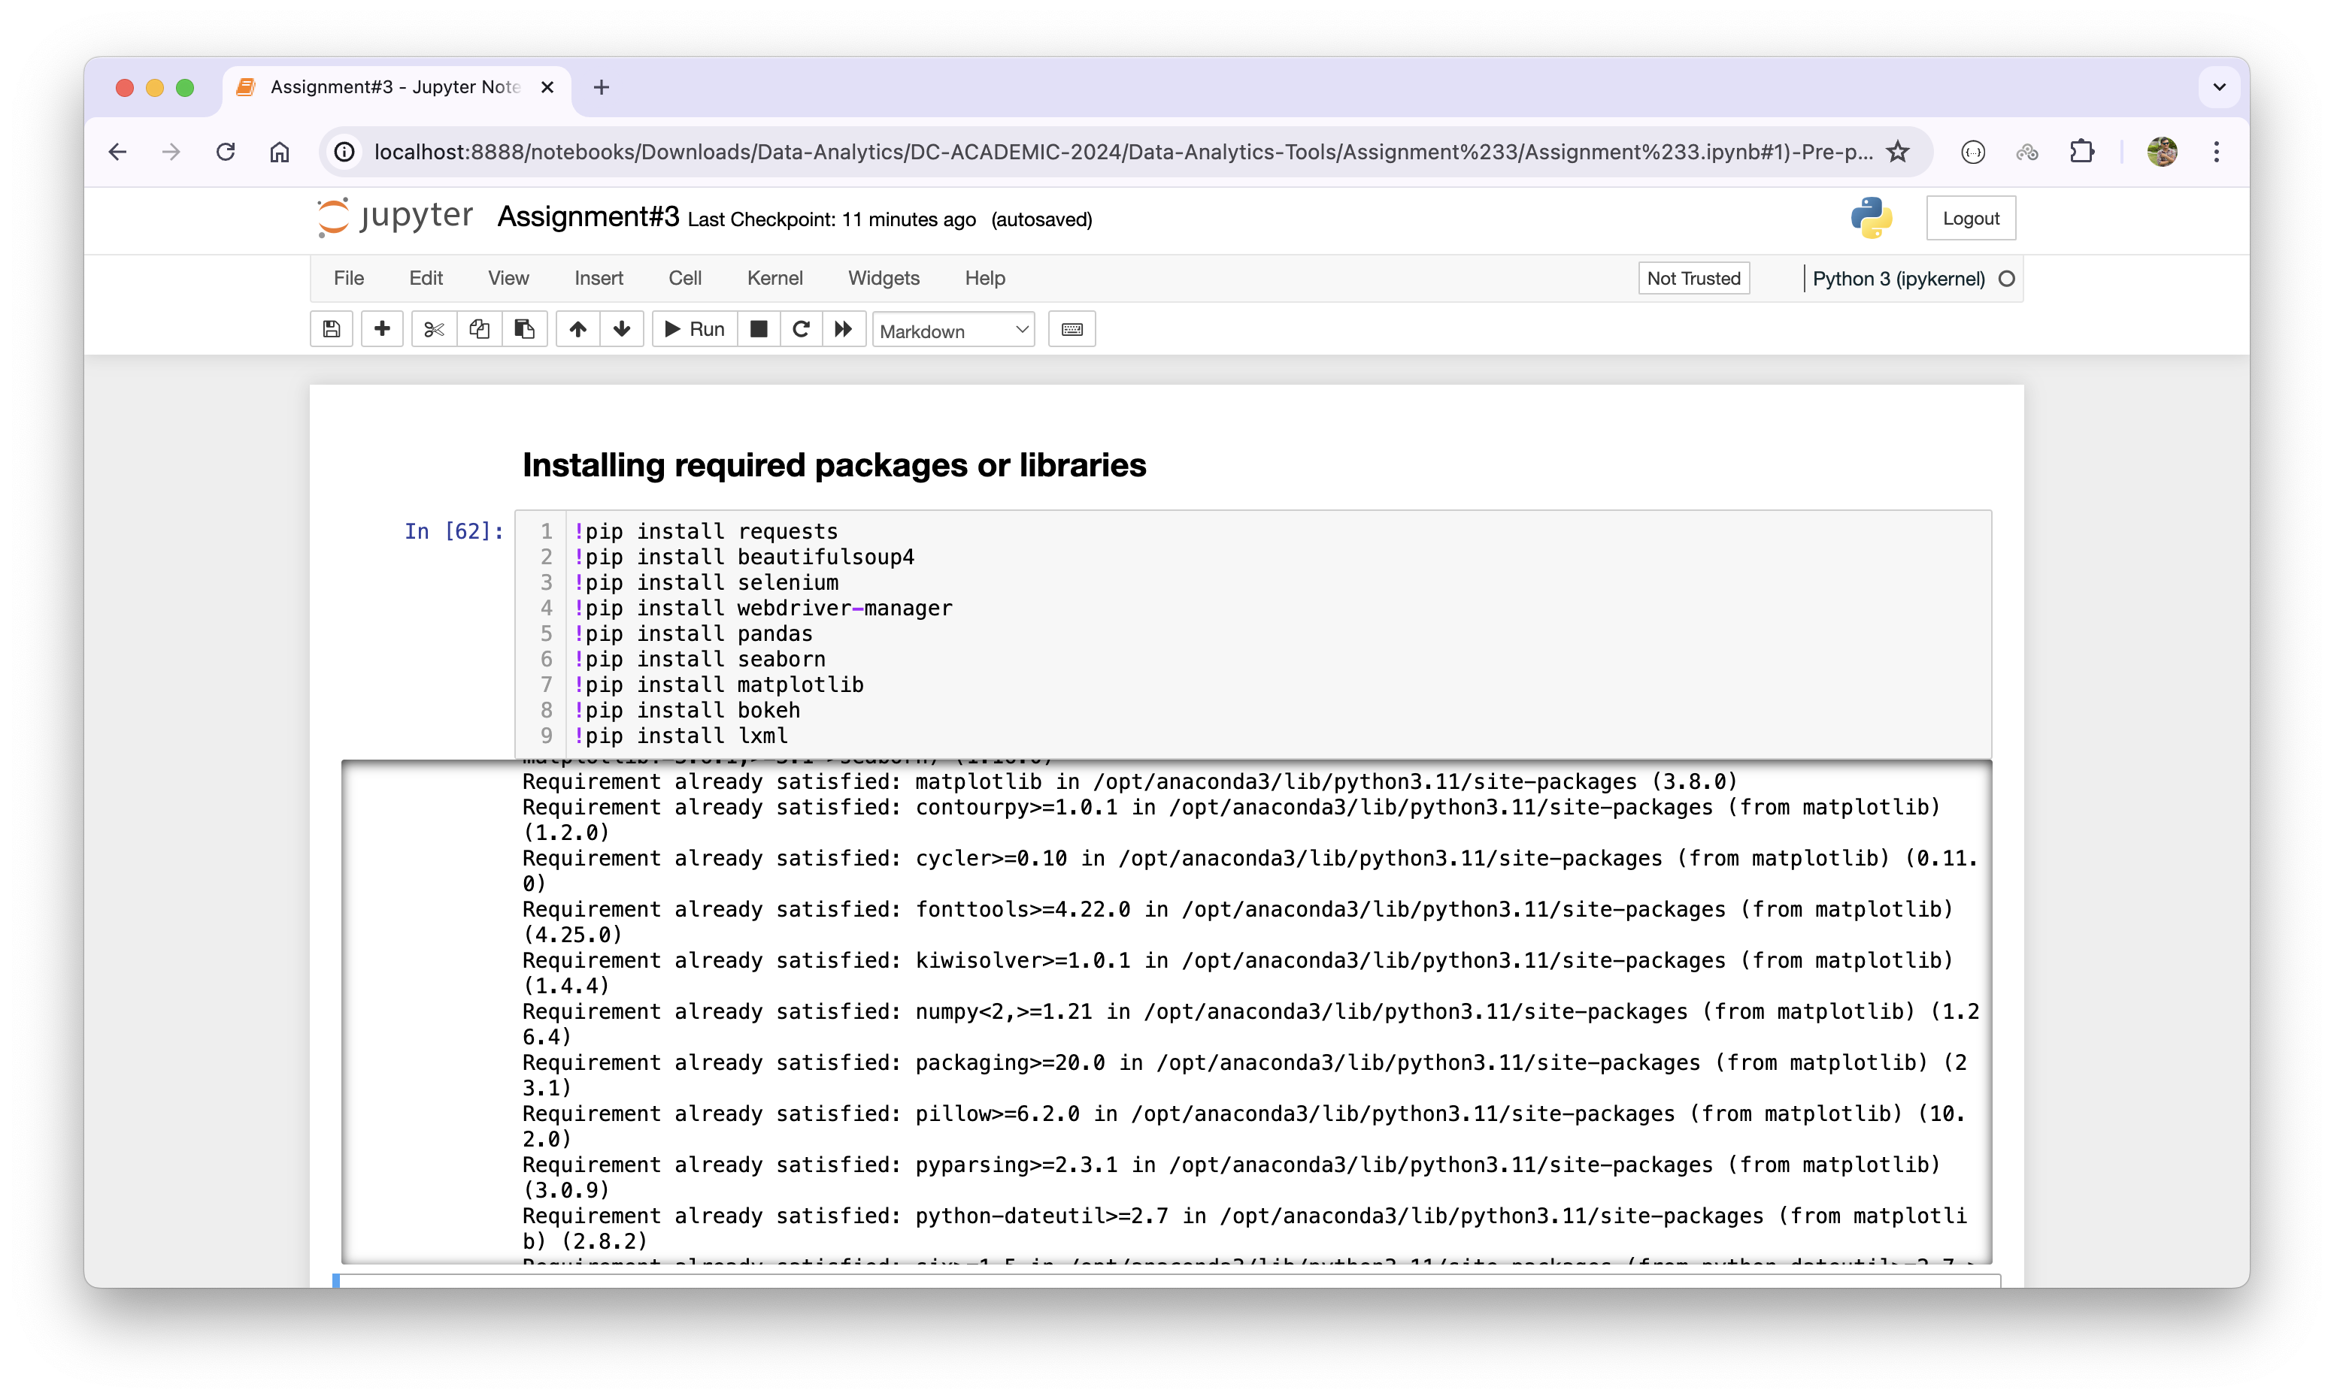

Once, packages are installed, I have imported following packages and libraries:

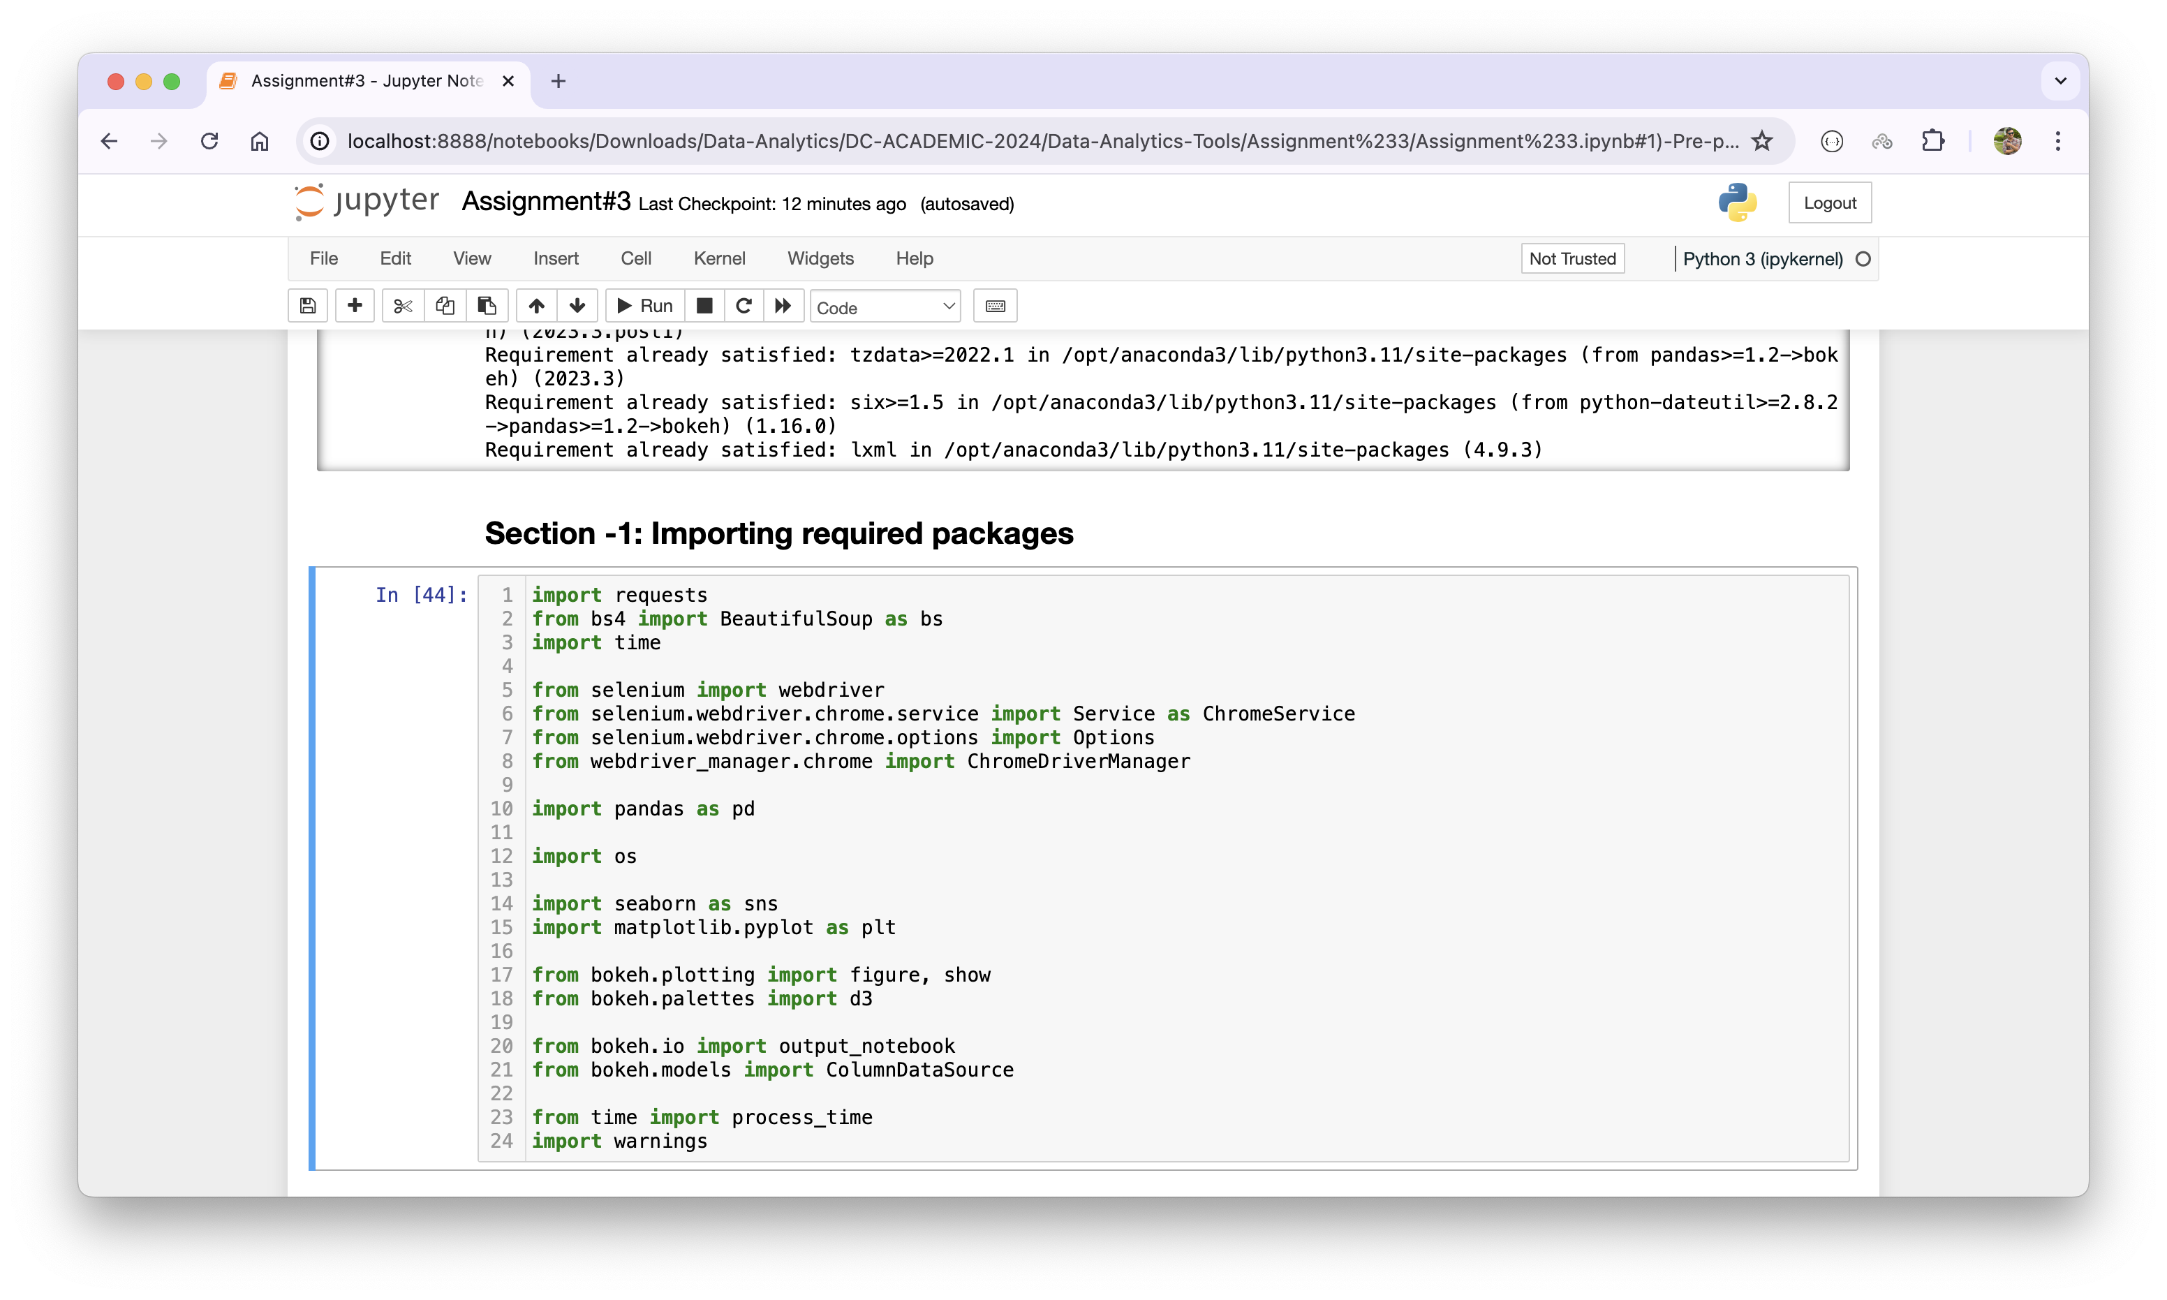

**Section – 2: Scraping the Amazon Best Selling Books (100 Books)**

In this section, I have scraped 100 books from the Amazon’s best-selling books’ URLs. First of all, I have created following helper functions which will help me to later in the project. Using these functions, I do not have to write same again and again:

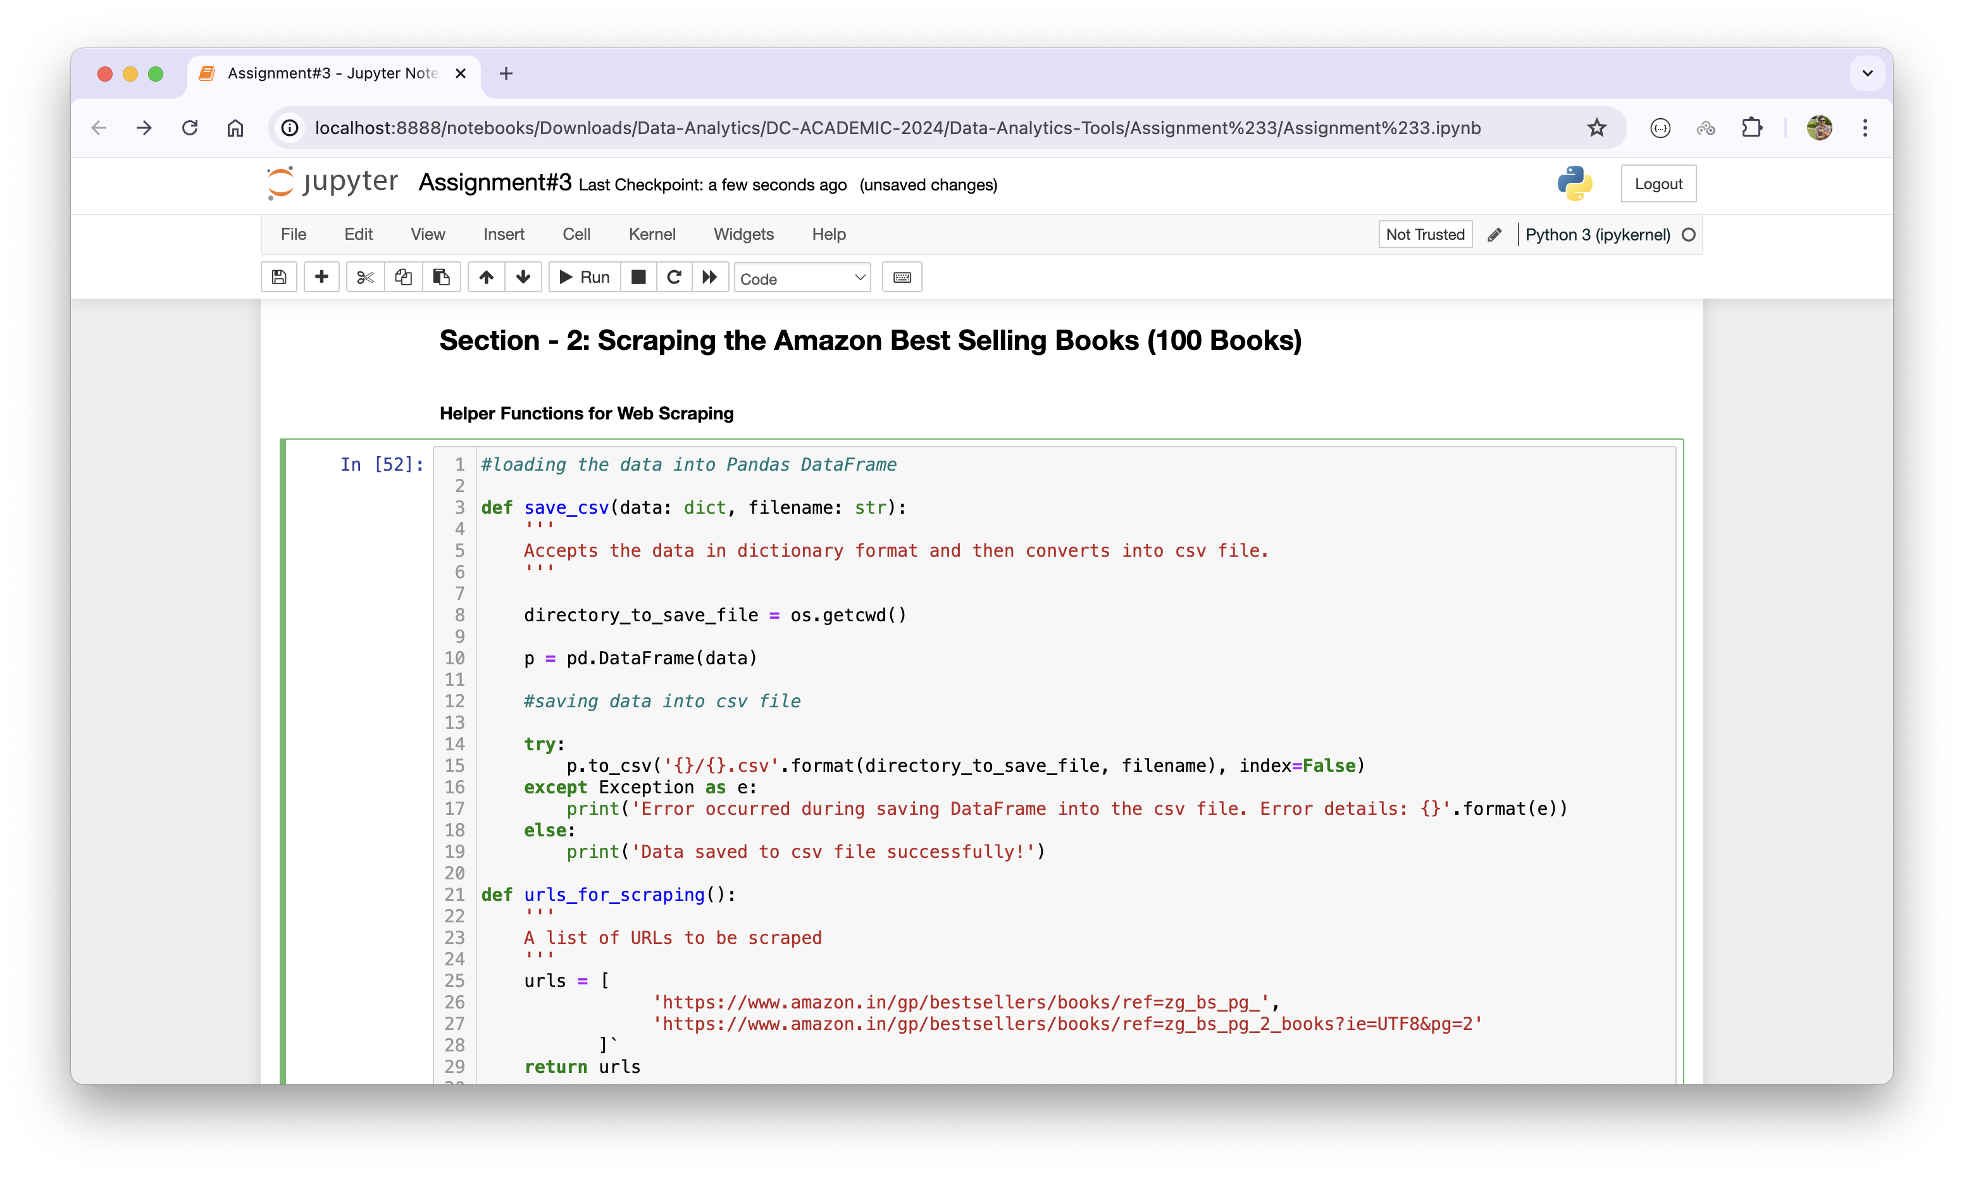

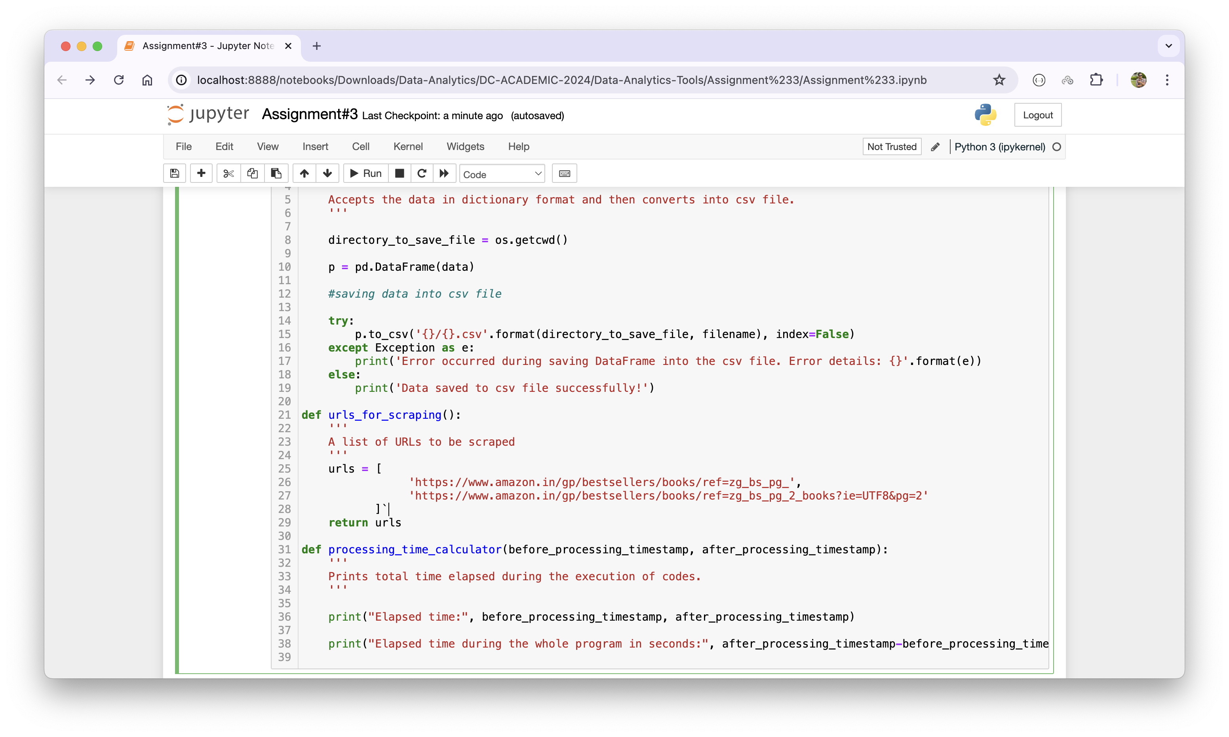

I have created three helper functions with the following purposes:

* save_csv(): It helps to save Pandas DataFrame into a .csv file with the given name.
* urls_for_scraping(): It makes easier for us to put a list of URLs to be scraped from and then returns a list so that we can use it later in the code.
* Processing_time_calculator(): It helps to calculate the total time (in seconds) needed to execute certain program. In our case, the program will be three different web scraping libraries; BeautifulSoup, lxml, and RegEx (re).

1. **Implementing web scraping using Beautifulsoup in Python:**This is the first package that I will be using to scrape book’s data from the Amazon best selling URLs. Firstly, I have declared an empty Python dictionary so that I can update the values on it later. Then I have created a class called ‘AmazonScraper’ with a constructor. I have created some methods such are scrape, get_book_name, get_author, get_price, get_customers_rated, get_rating, etc. These methods helps to extract the information as their name suggests such as ‘get_book_name’ scrapes the book name from the provided URL and so on.

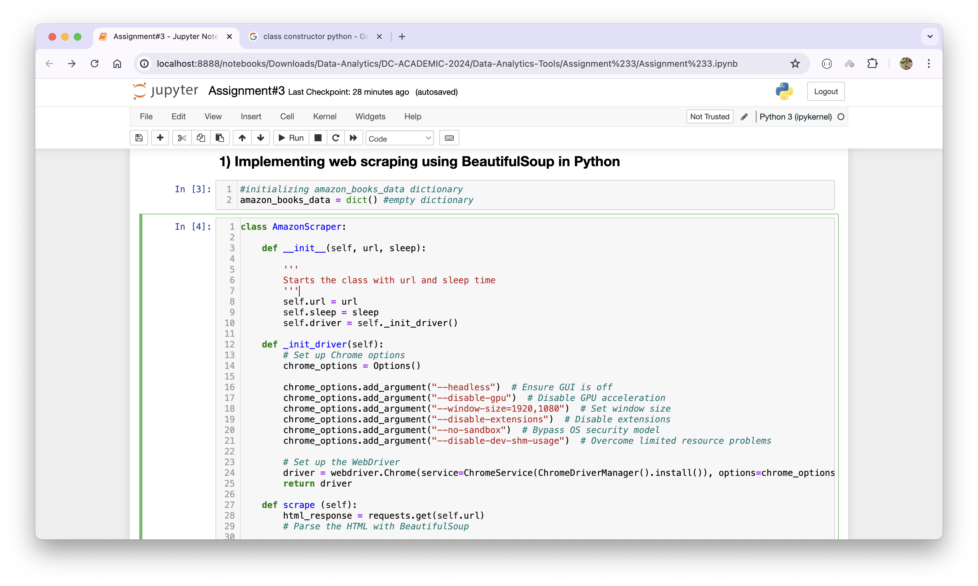

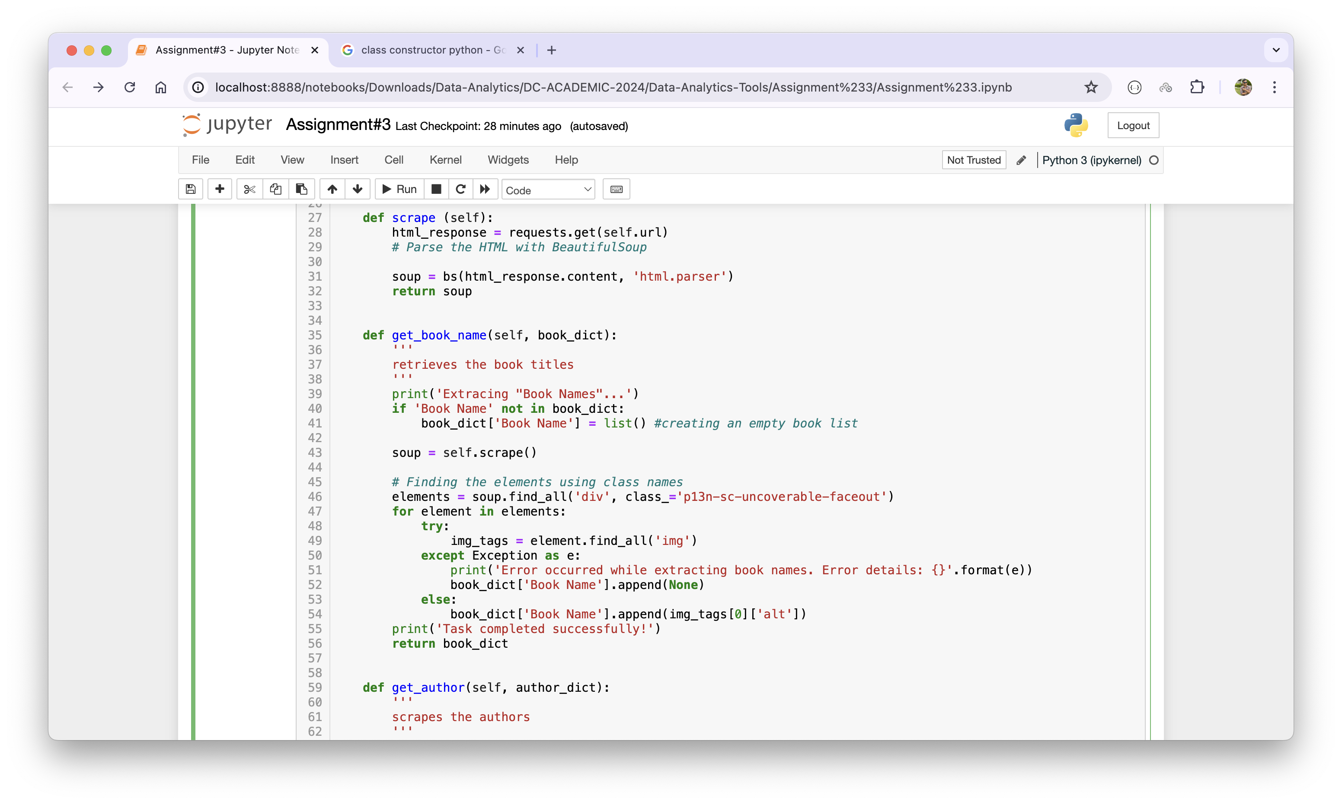

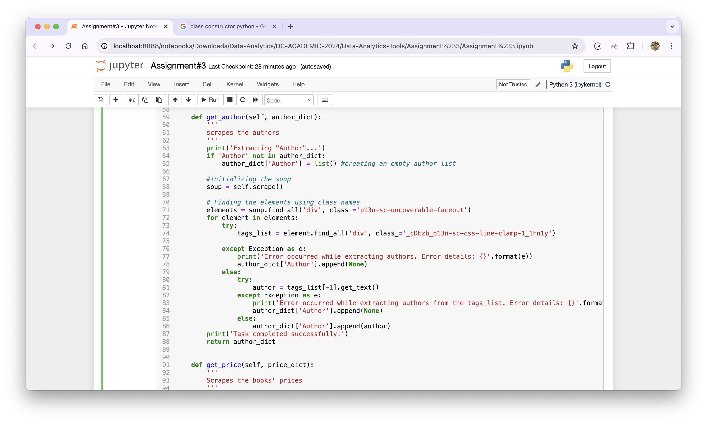

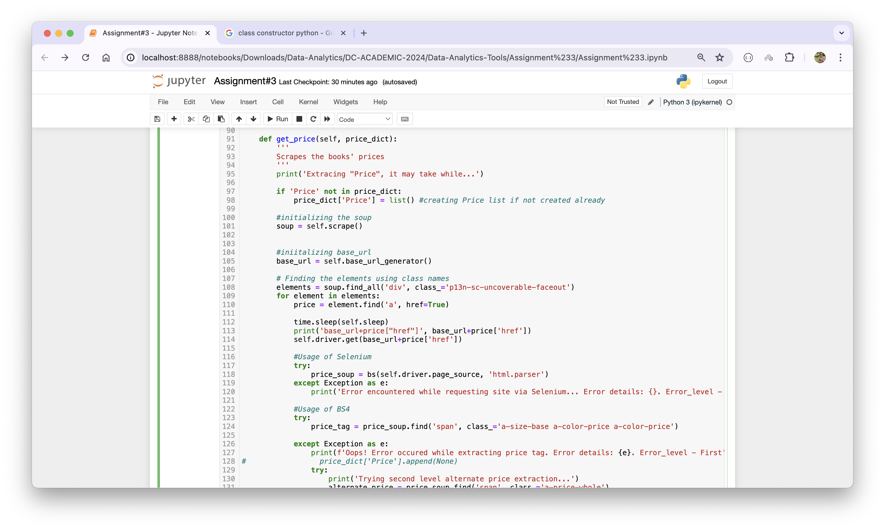

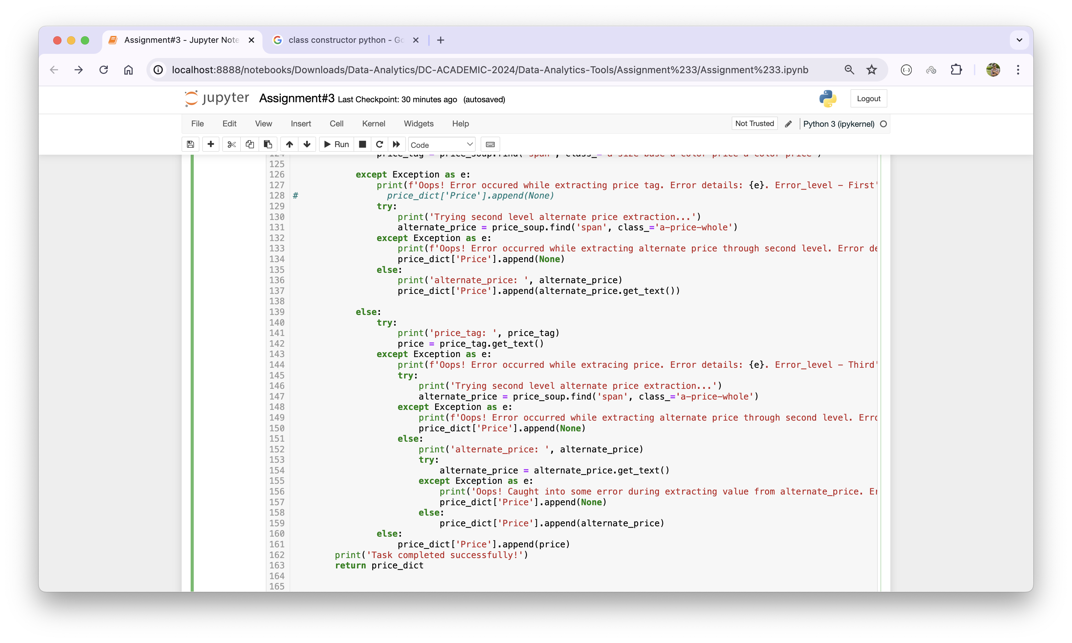

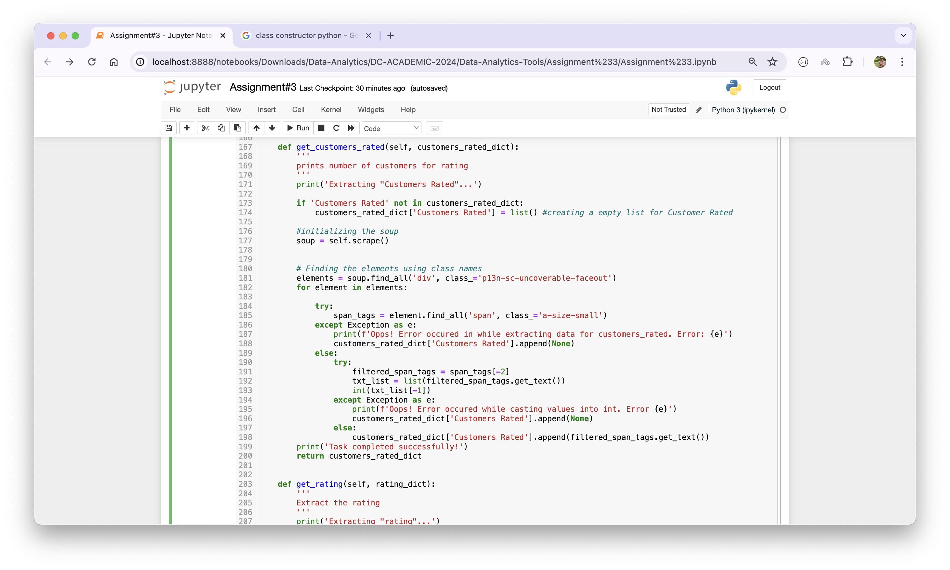

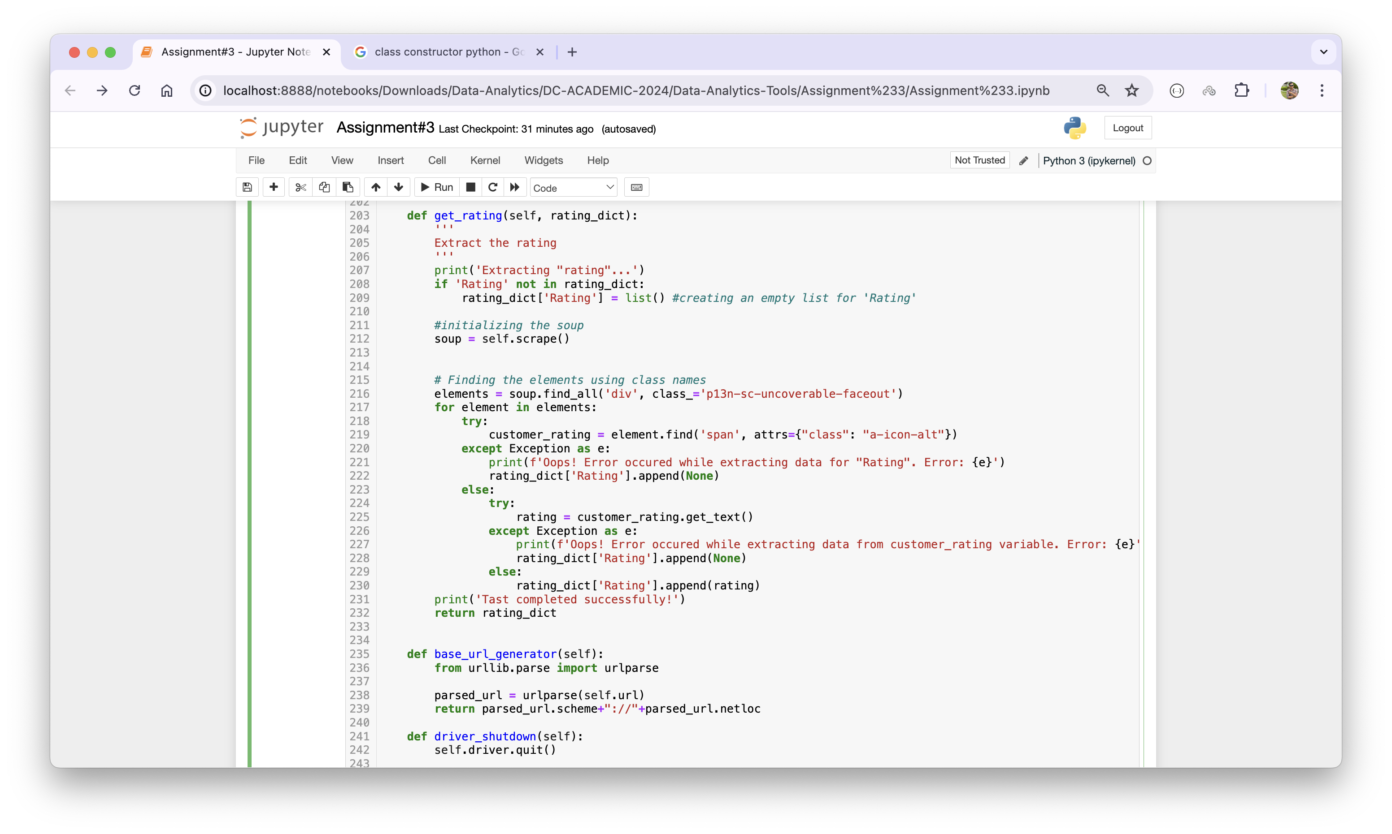

The main reason to write separate method for each variable (such as book name, price, etc.) is to have precise value for Price. When we extracted the price using home URL of best-selling book, it is nearly impossible to capture the displayed price because the price is being rendered using CSS pseudo-elements ::before and ::after. It is because ‘requests’ package scrapes the raw html (static page) rather dynamic pages built through CSS or JavaScript. Thus, I used another alternative to get the actual price. For this, I have gone through the book’s individual URL and extracted the real price. I have used the ‘Selenium’ package and Chrome as headless browser to send request. To keep all the options in Chrome, I have created a private method called “_init_driver”. It is needed because each time I send a request to all the individual URLs (almost 100 URLs), Amazon’s server kicked me off saying; human verification is needed. So, the combination of Selenium and the Chrome assisted to get the page for actual price. However, for other package, lxml and regex, I have used only home URL and I haven’t gone too deep which I shall be discussing in the following part of the report.

After writing class and its methods, I ran the code as below:

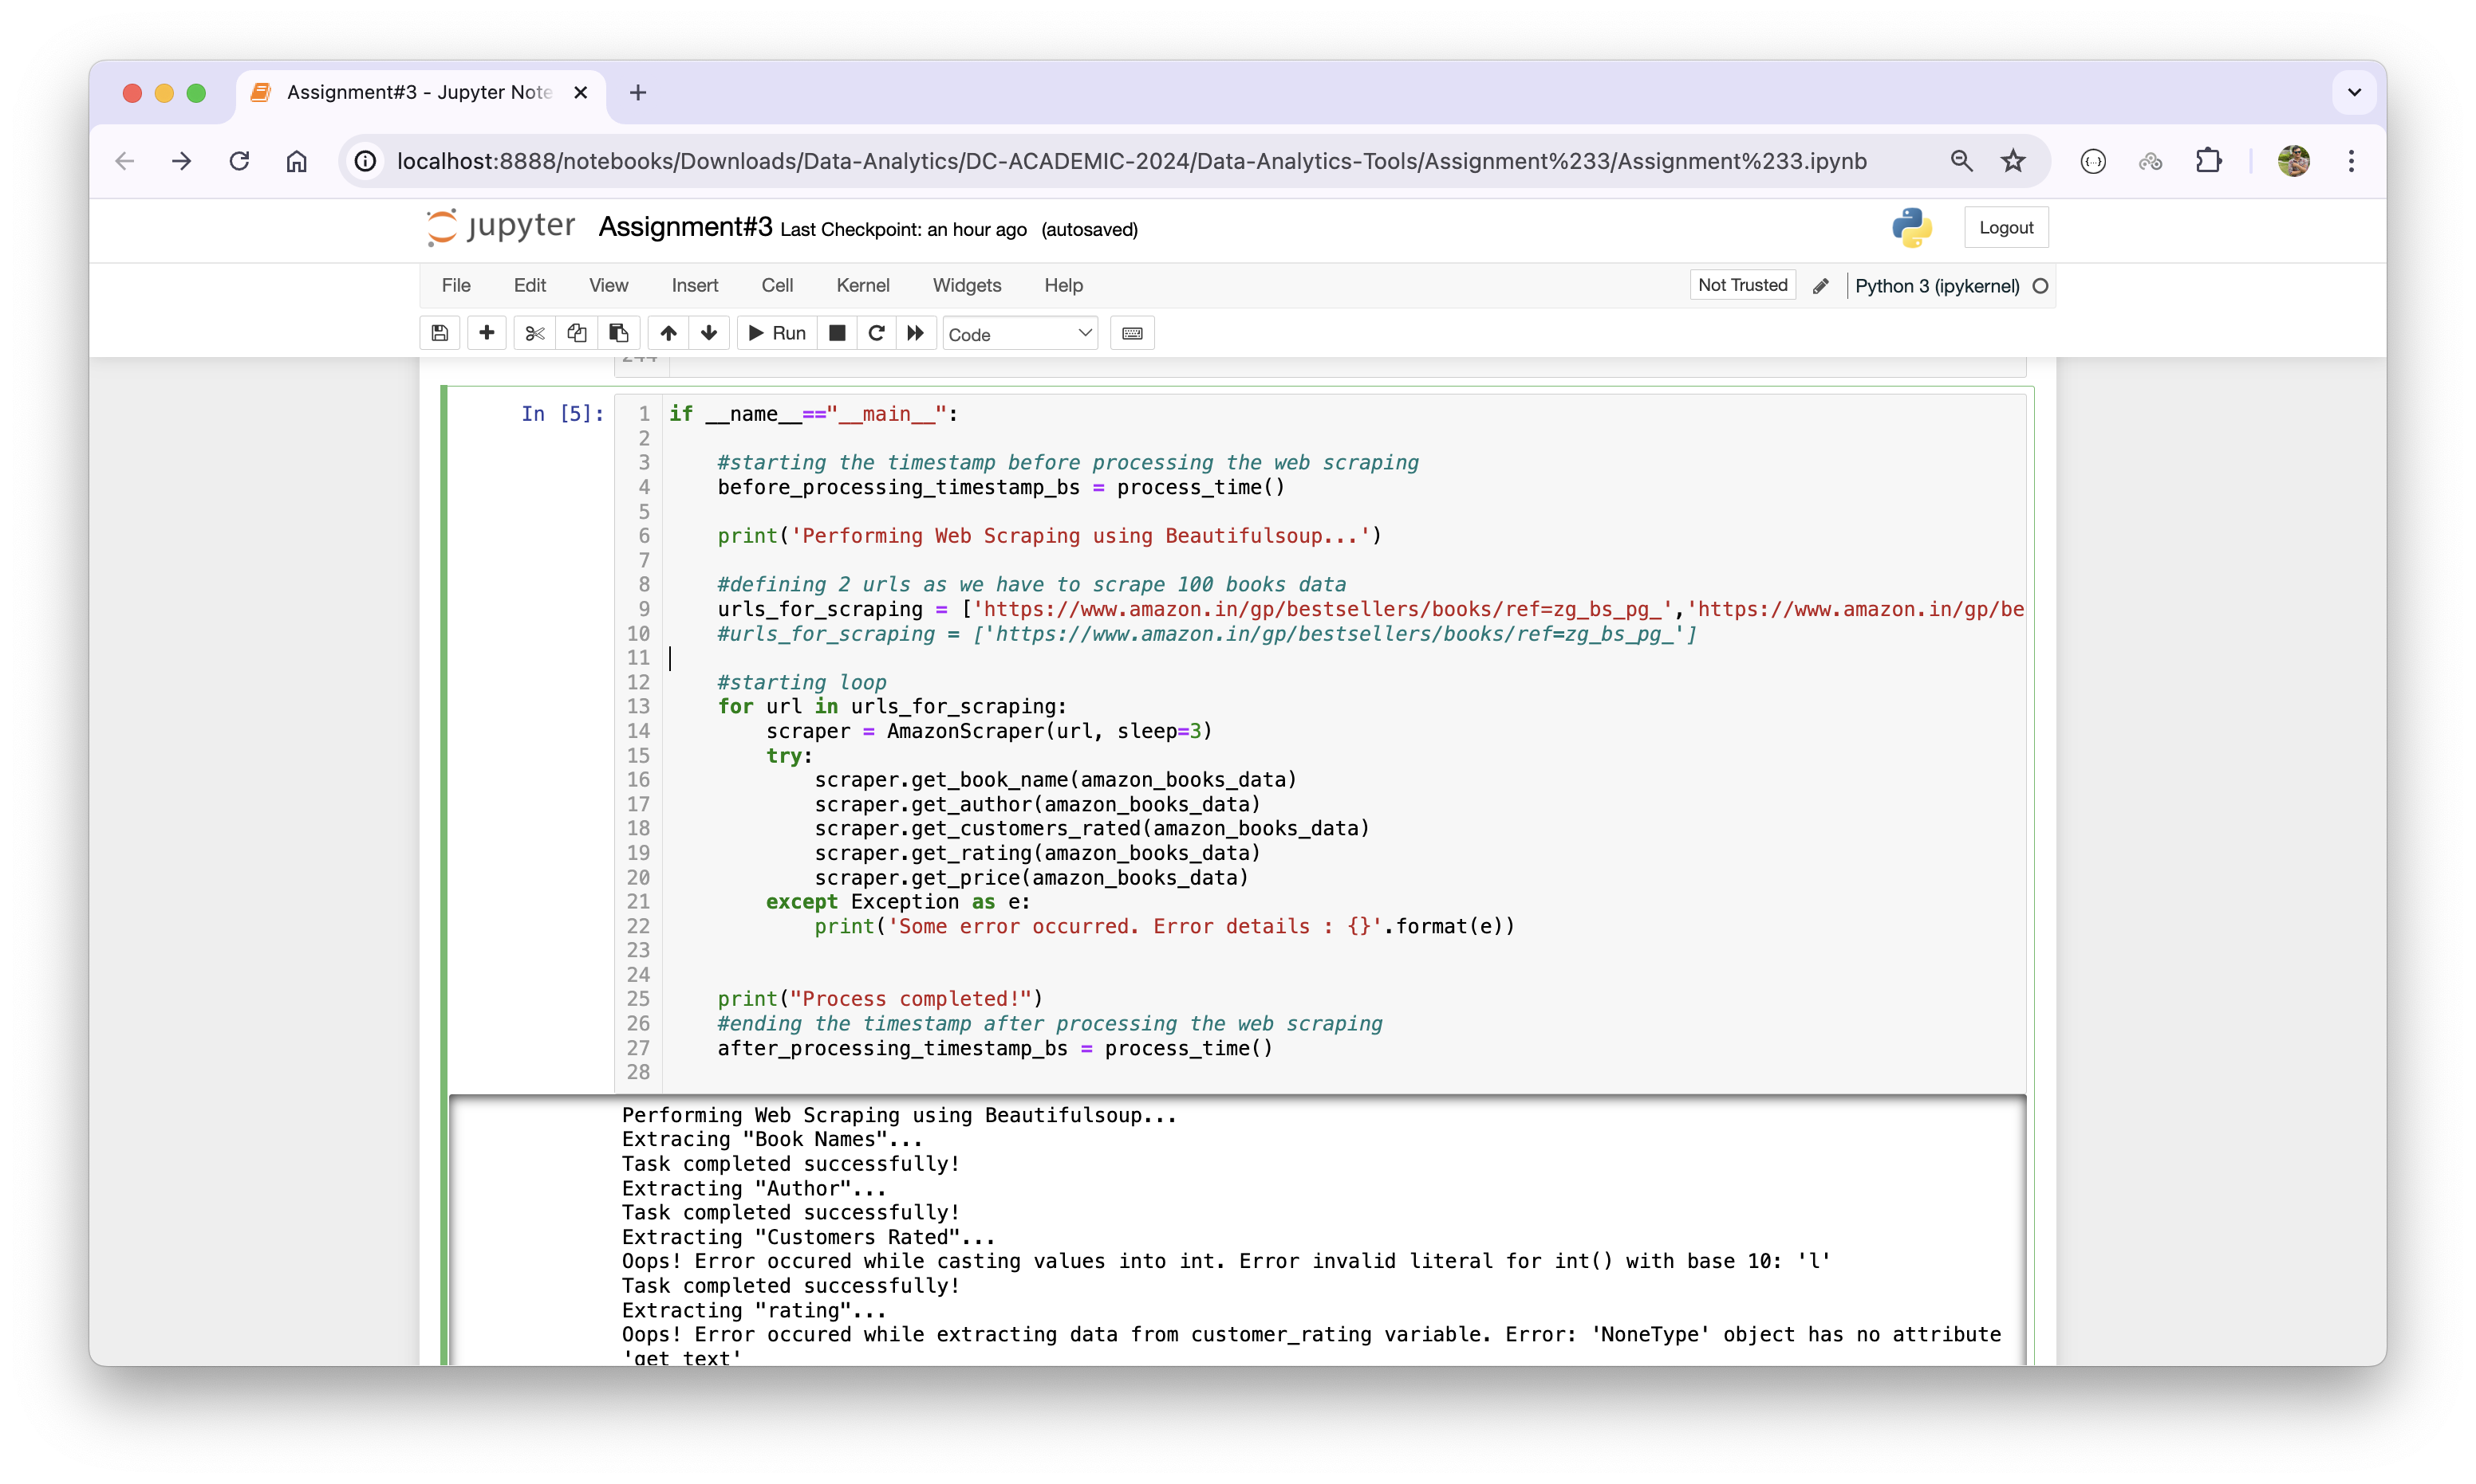

In the code, I have called process_time() function in the beginning and at the end of the code snippet because I want to track the time required to execute the program. This also has been asked in the assignment. Further, I have defined the URLs to be scraped in a variable called ‘urls_for_scraping’ as a list then I have executed for loop to scrape book name, author, customers rated, rating, and price.

Process output looks like something below:

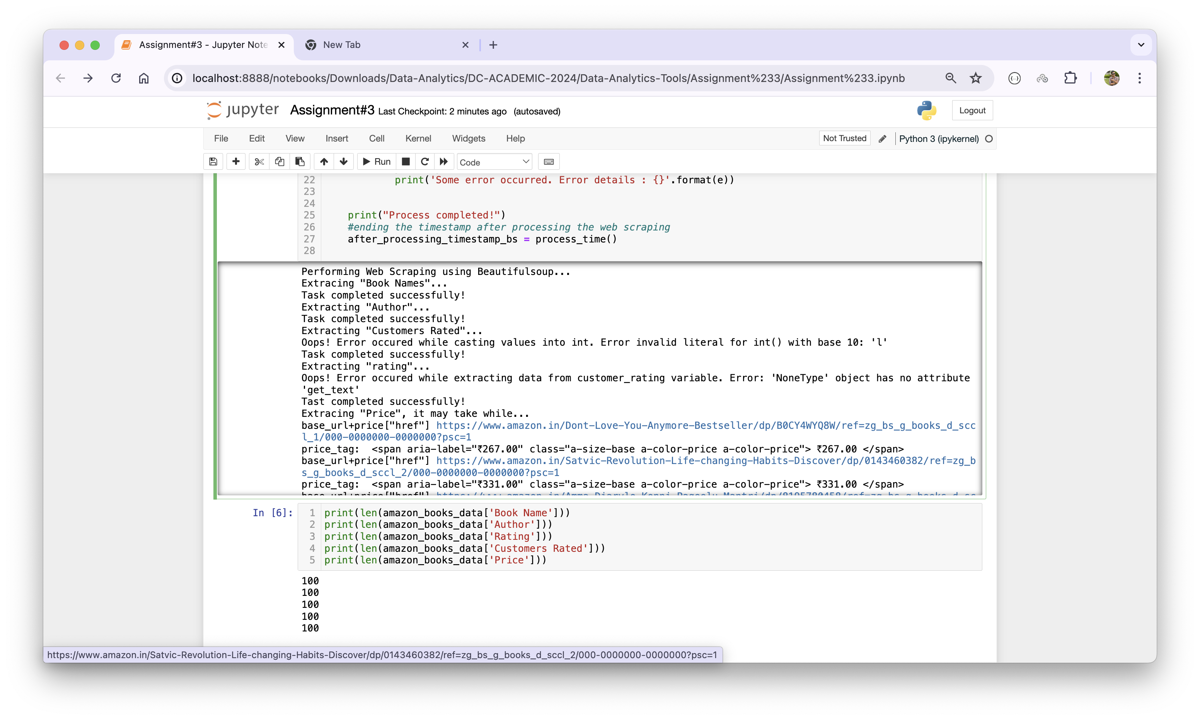

When program is executed successfully, I have checked each variable’s length because we need to have 100 books.

**Loading the scrape data to Pandas DataFrame**

Once the data is extracted in Python dictionary, I have loaded it into the Pandas’ DataFrame because it helps us to save data into .csv file as well as to perform data cleaning and then analysis (EDA).

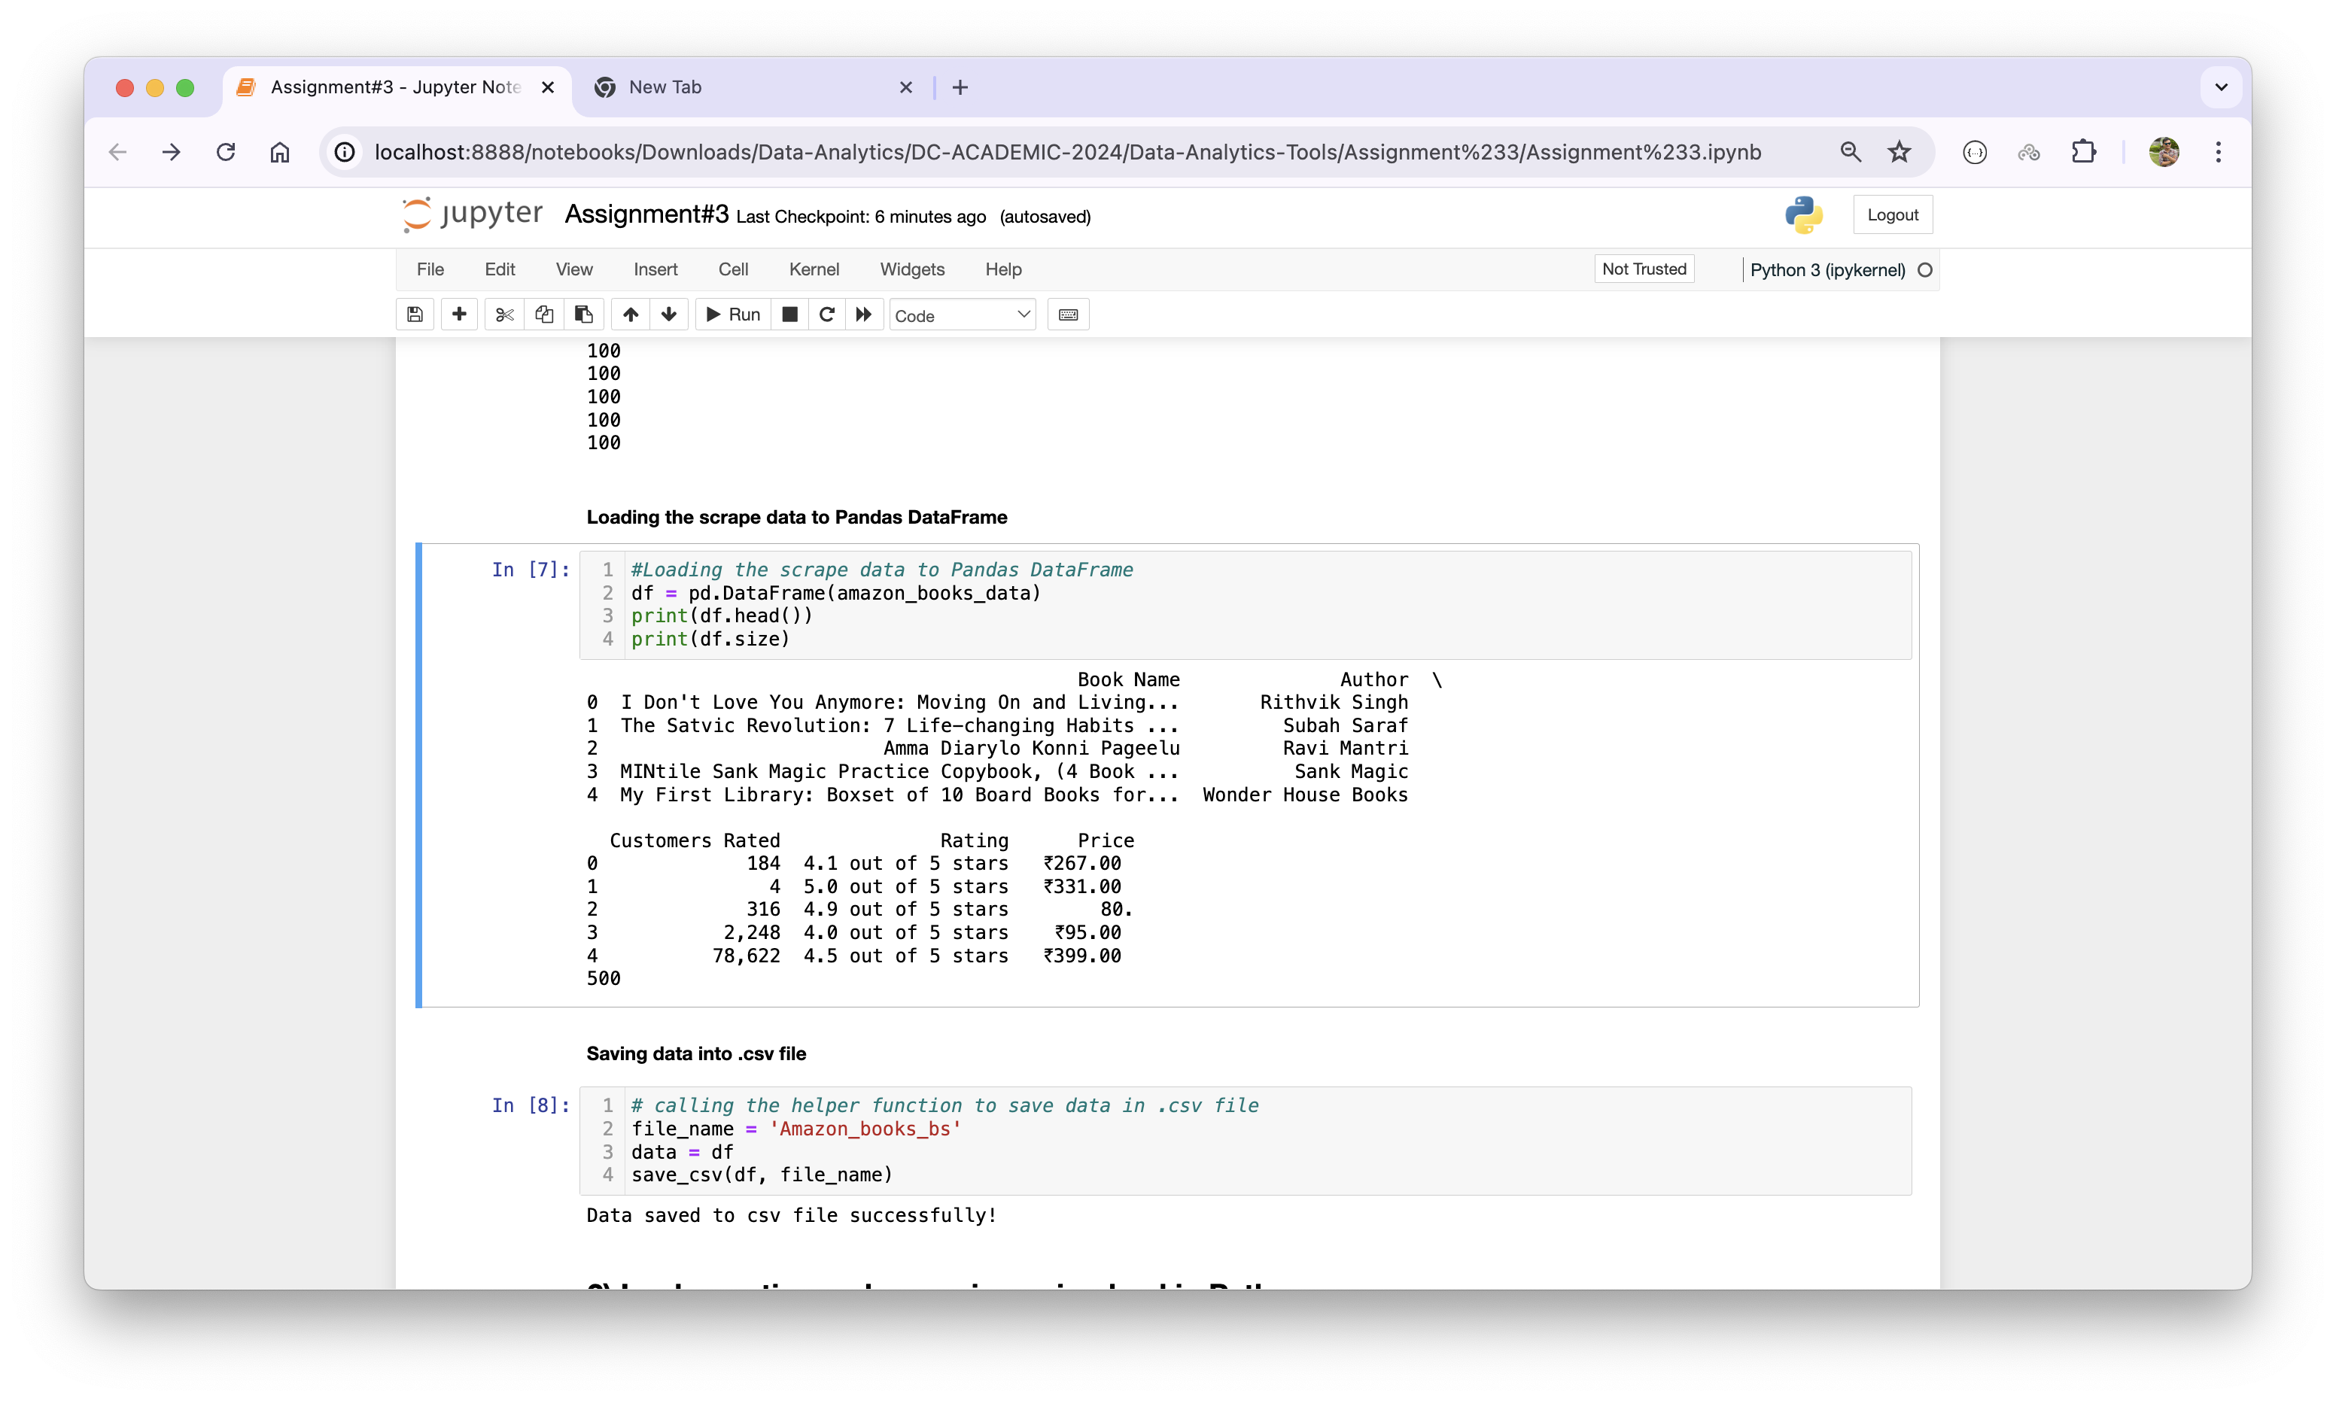

1. **Implementing web scraping using lxml in Python**

Initially, I have installed the ‘lxml’ package and imported it into the notebook along with other packages (pandas and requests). Then I have instantiated an empty Python dictionary called ‘data_lxml’ which shall be used to store scraped data.

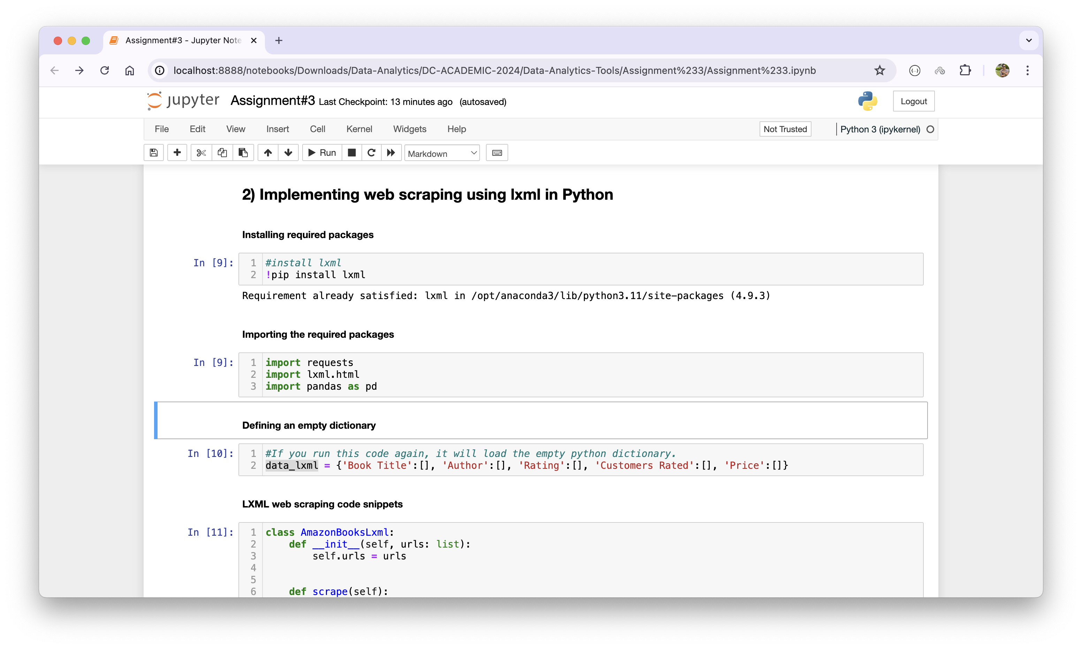

After these things, I have created a Python class called ‘AmazonBooksLxml’ with a constructor and a method called .scrape(). Once an object is created through this class, web scraping can be started by calling the .scape() method which extracts Book Title, Author, Rating, Customers Rated, and Price. Following are the codes regarding it:  
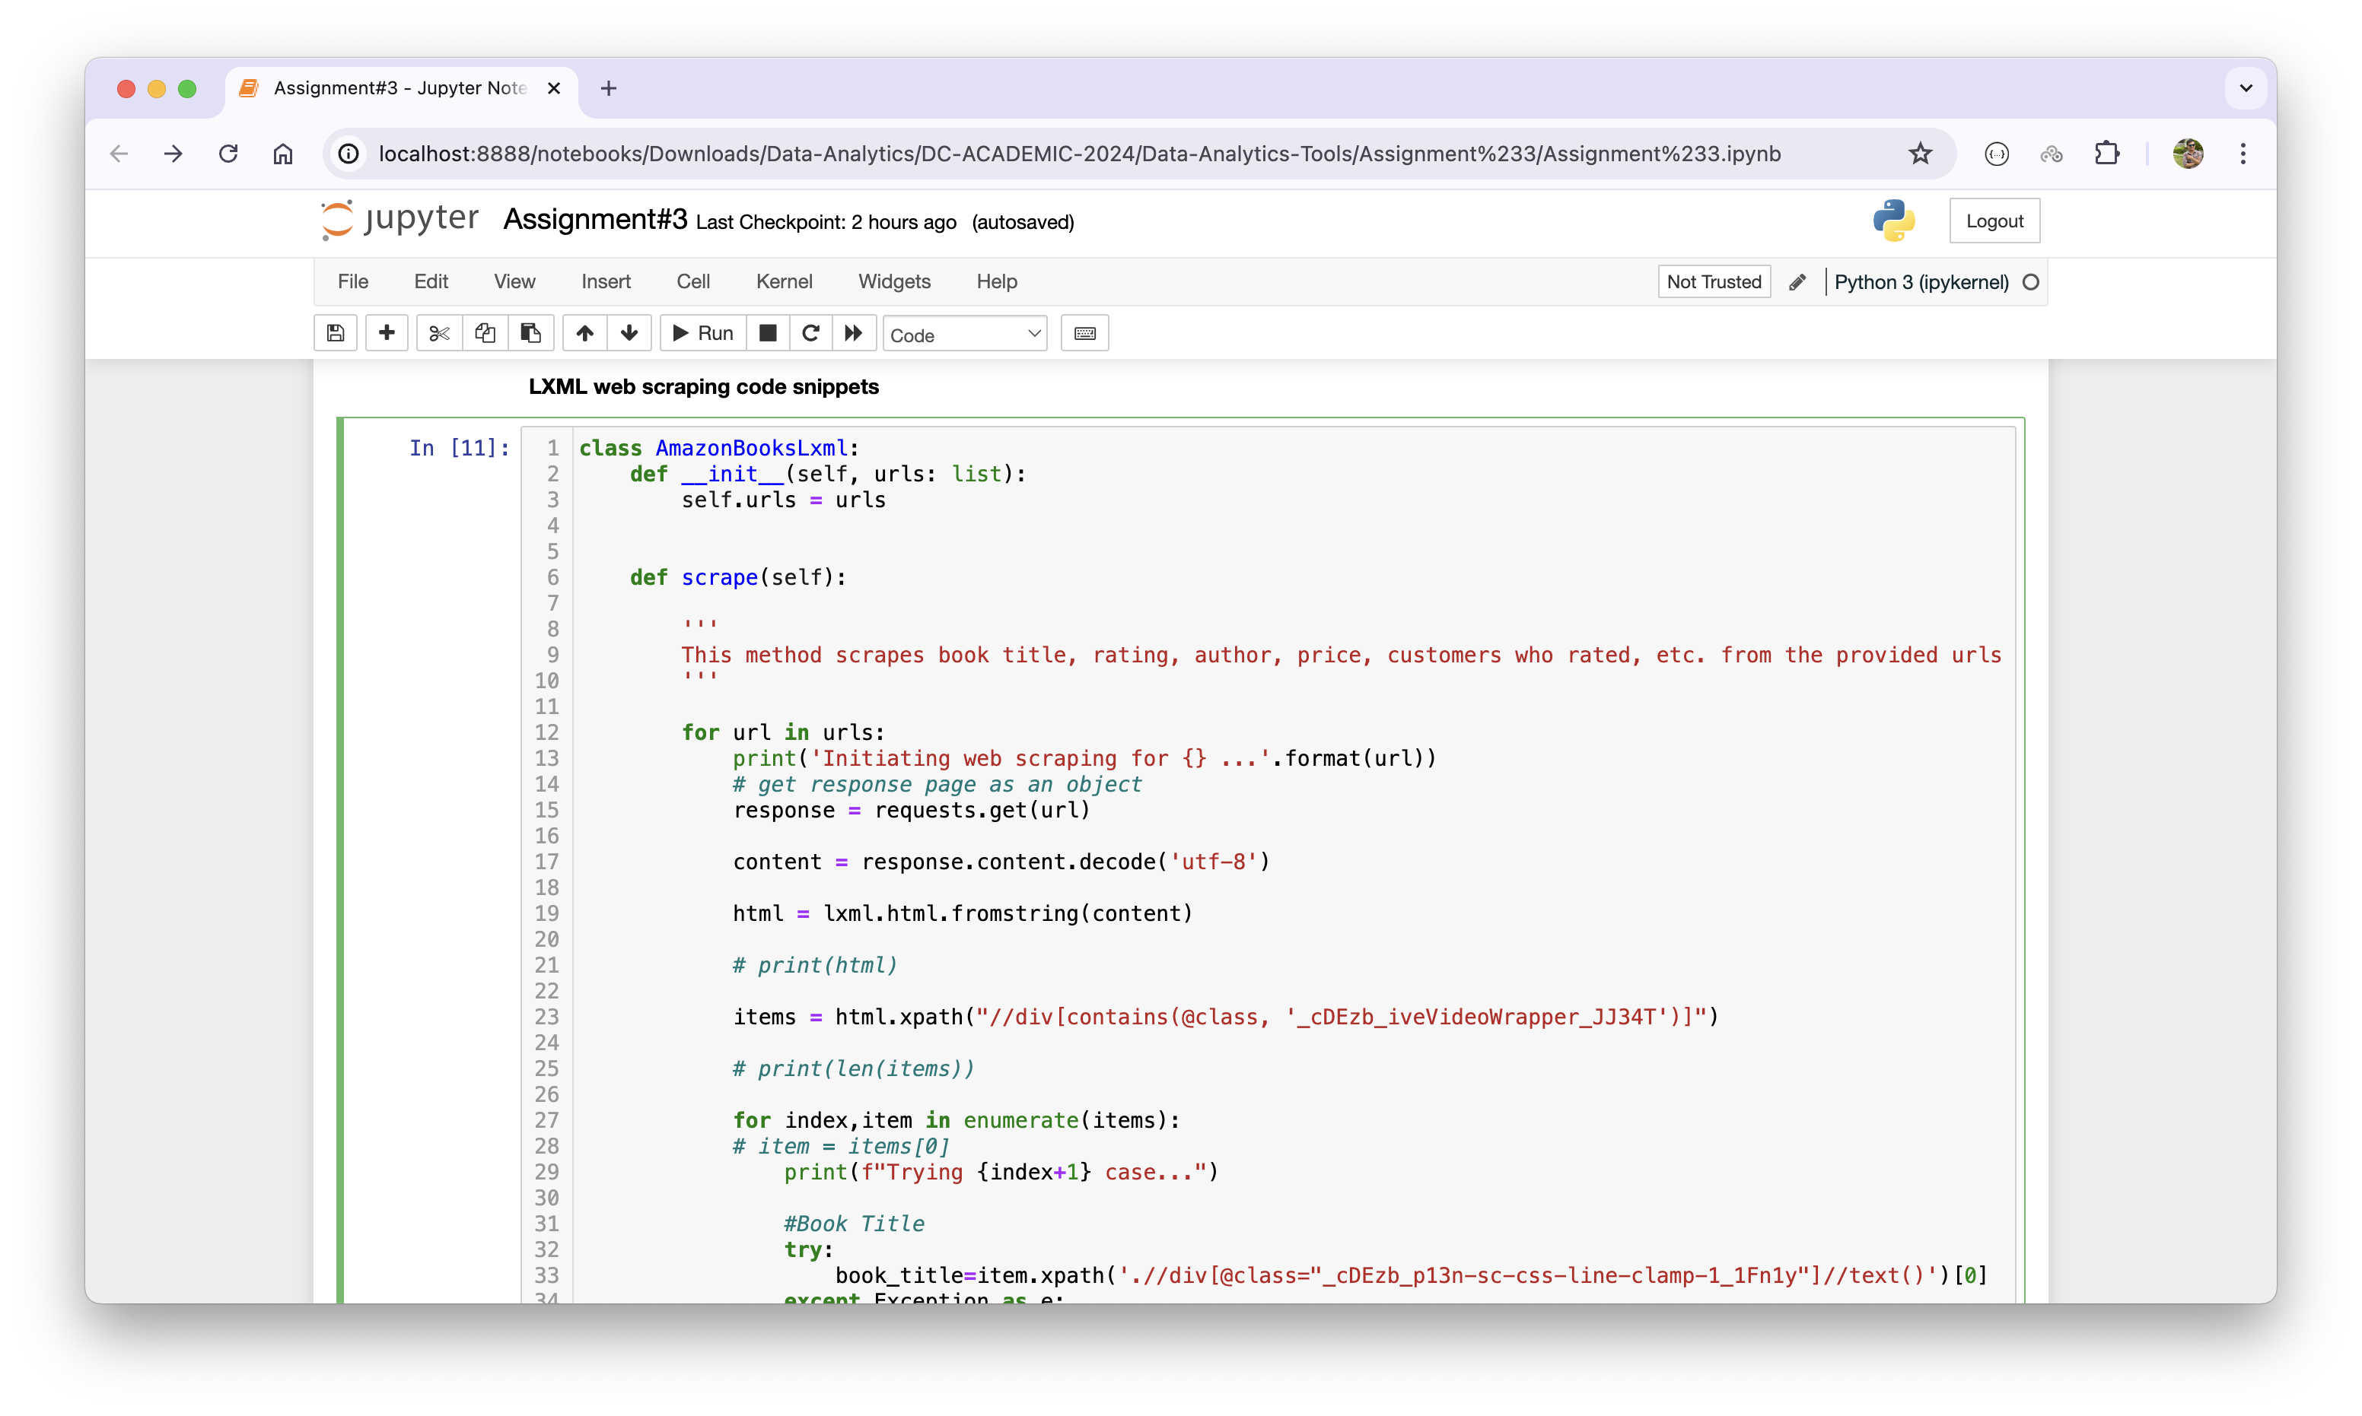

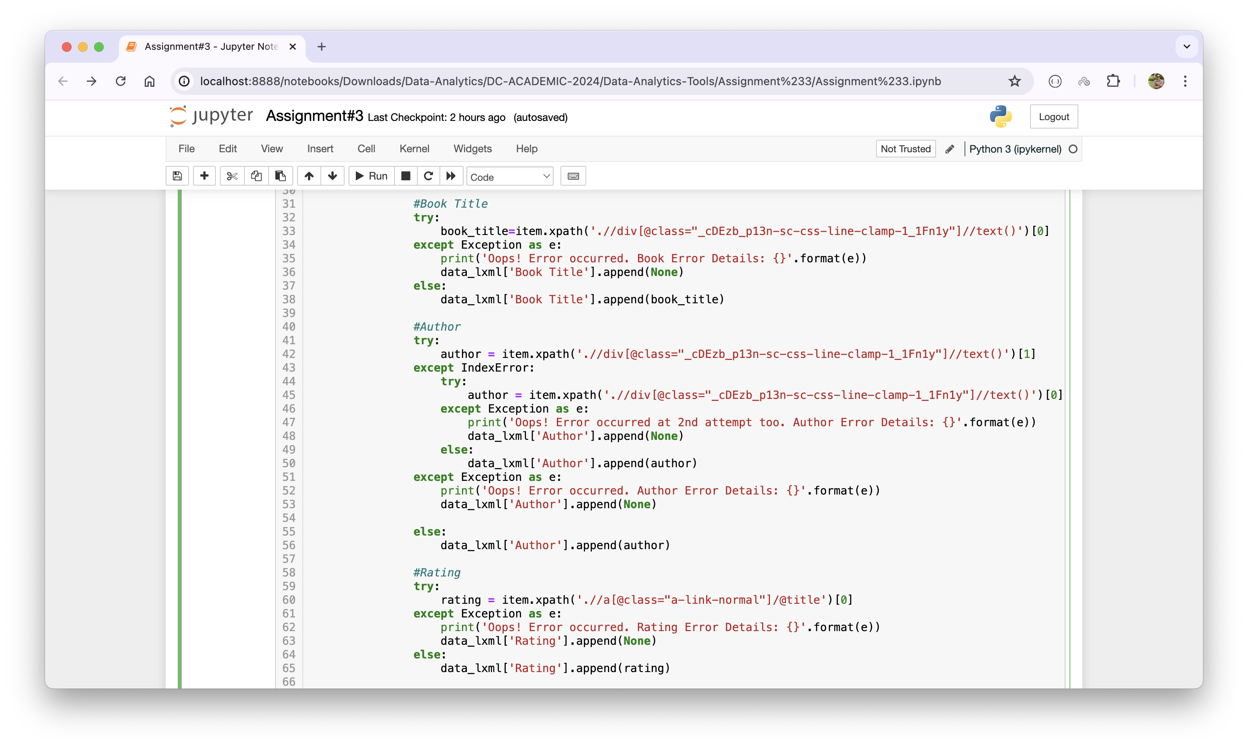

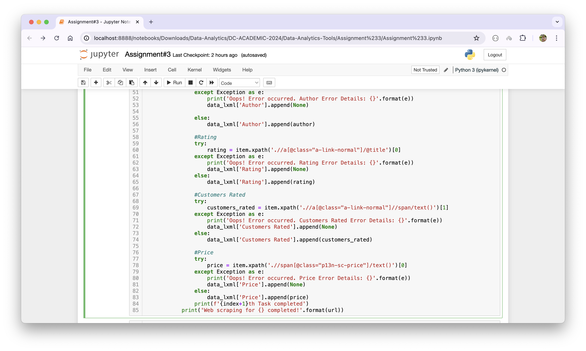

Once the class and the method is created, then I created an object called ‘scraper’ and extracted the information from the provided URLs as below:

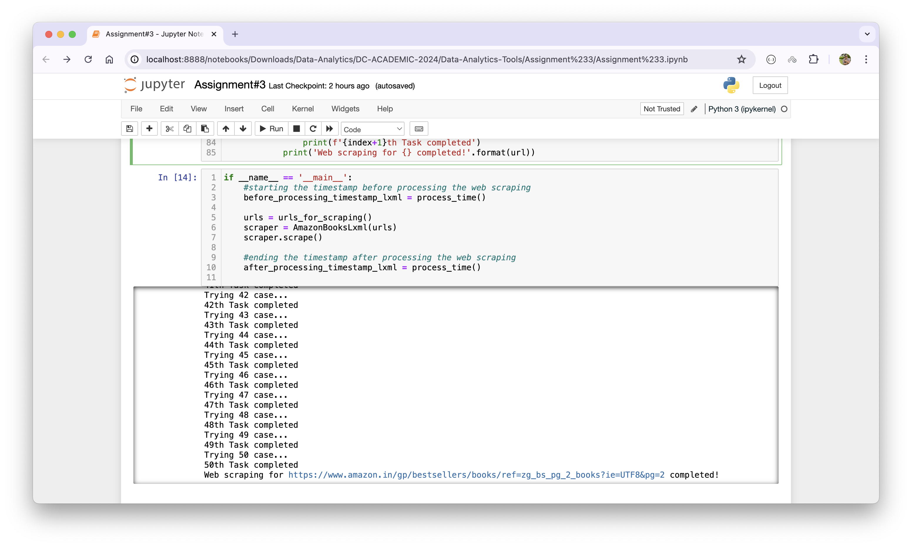

Here, same as in the earlier step, I have created two variables; ‘before_processing_timestamp_lxml’ and ‘after_processing_timestamp_lxml’ to store processing time by calling a function called process_time(). Lastly, I loaded the extracted data in Pandas’ DataFrame and then saved it into a .csv file called ‘Amazon_Books_Data_lxml’ as below:

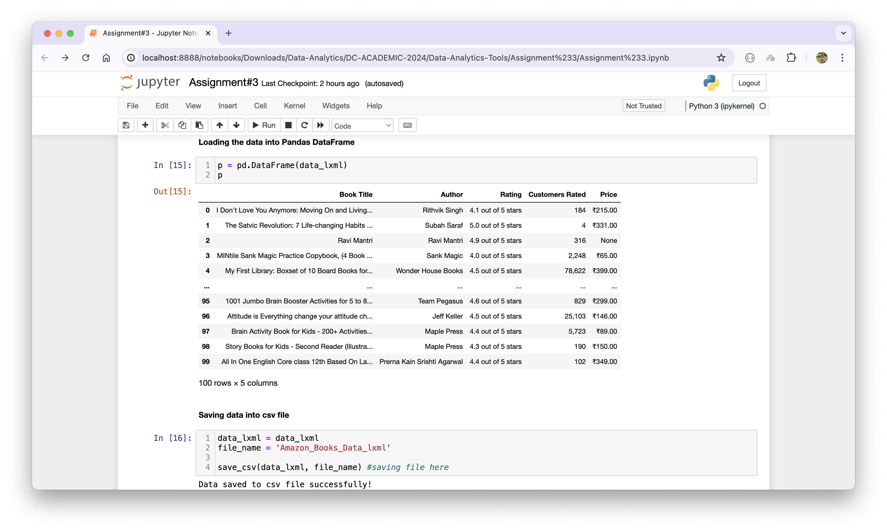

1. **Web Scrapping using RegEx (re)**

Under this part of the section, I have extracted the information from the provided URL using the Regular Expression (RegEx or ‘re’). RegEx is a sequence of characters which is kind of a pattern that is used to search in a string (Python Software Foundation, n.d.).

As in earlier steps, I imported the required packages and libraries. Then I initialized an empty Python dictionary in which, later on, we will update the extracted values for Book Name, Author, Rating, Customers Rated, and Price.

Further, using characters, special characters, and set of characters, I defined specific patterns for Book Title, Author, Rating, Customers Rated, and Price as below:

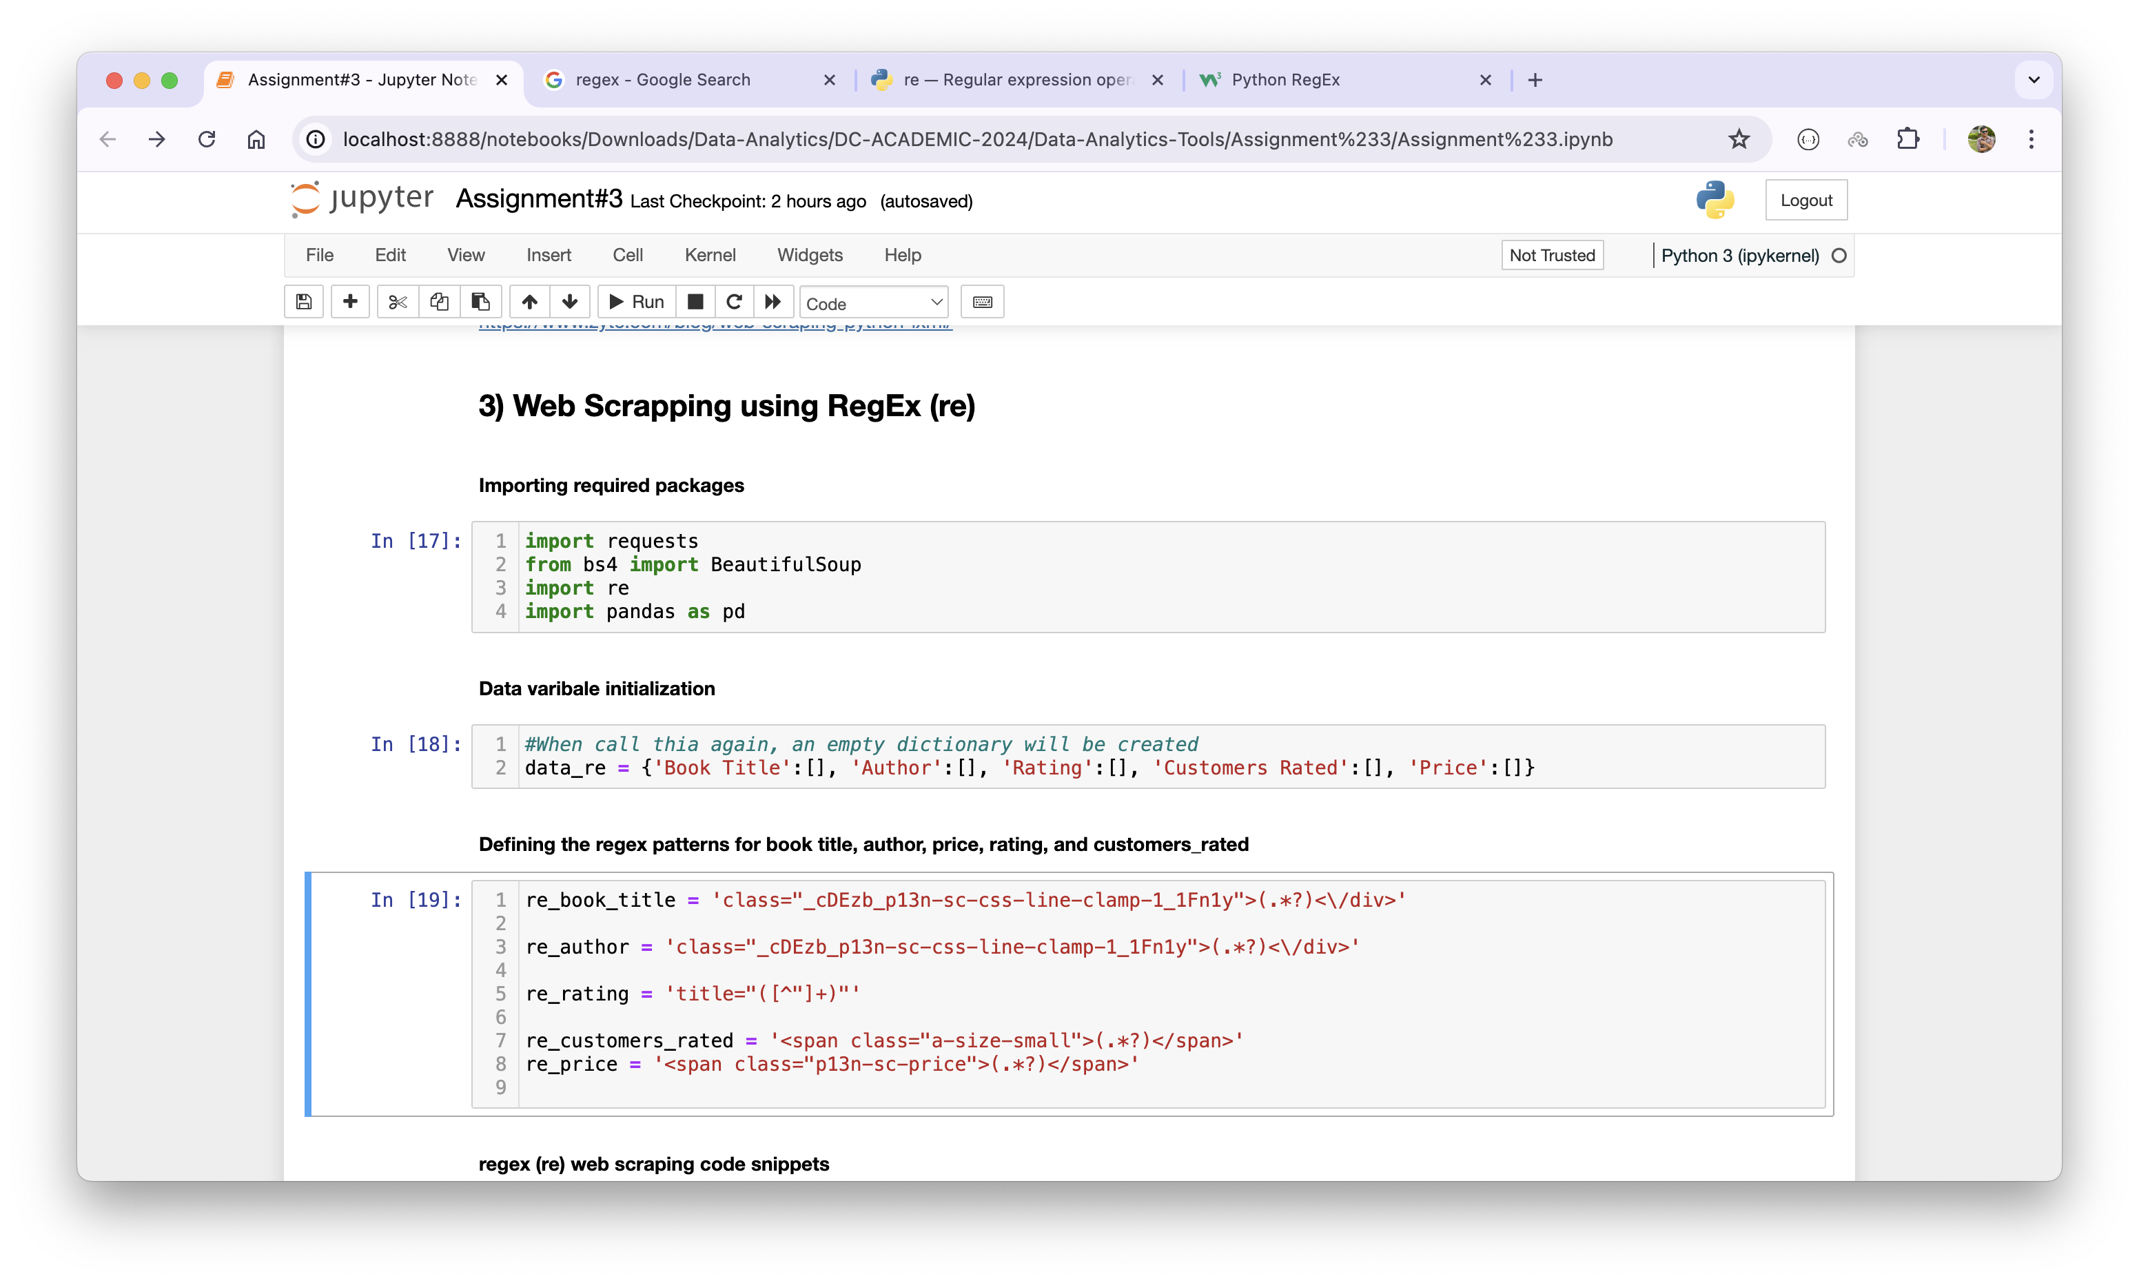

Right after it, I created a class called ‘AmazonBooksRegex’ with a constructor and a method called .scrape(). This method iterates over provided URLs and pull out the data for Book Title, Price, Rating, Customers Rated, and Author by matching characters mentioned earlier in the patterns and then saves into the Python dictionary called ‘data_re’.

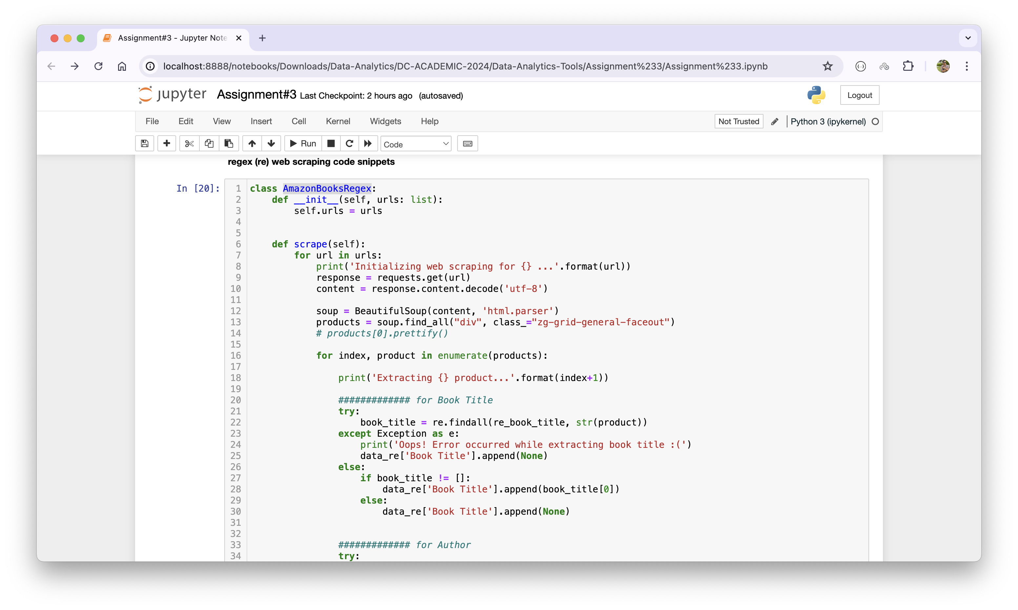

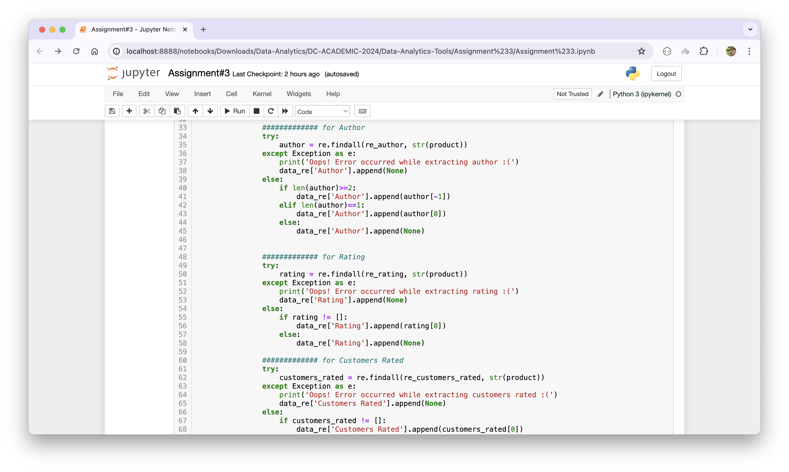

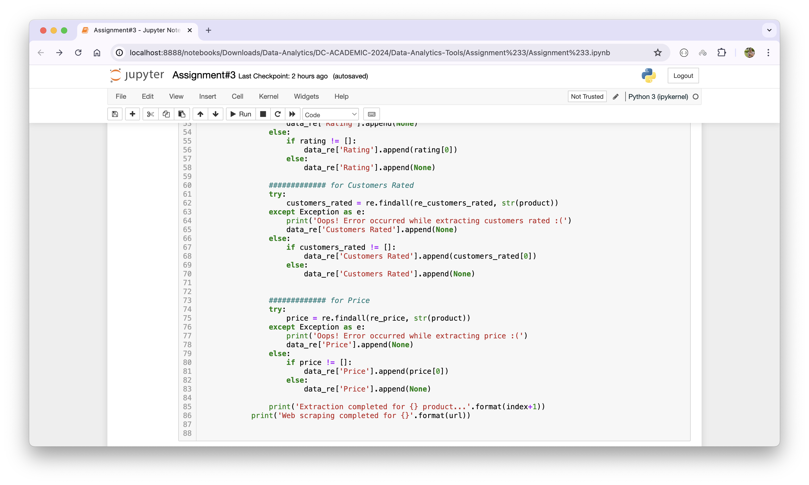

When class and its methods are written, I executed it with an object called ‘scraper’. Before it, I captured the time as ‘before_processing_timestamp_re’ and the time after the program execution as ‘after_processing_timestamp_re’. Once, the operation is successfully completed, I checked the length of each item of ‘data_re’ to make sure it contions 100 items in each variable. Furthermore, I saved the scraped data into a .csv file format as ‘Amazon_books_re’ as shown below:

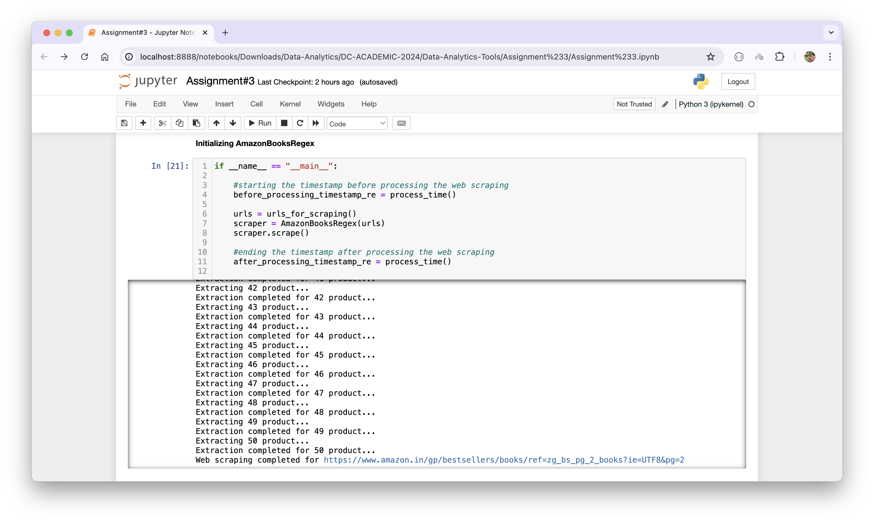

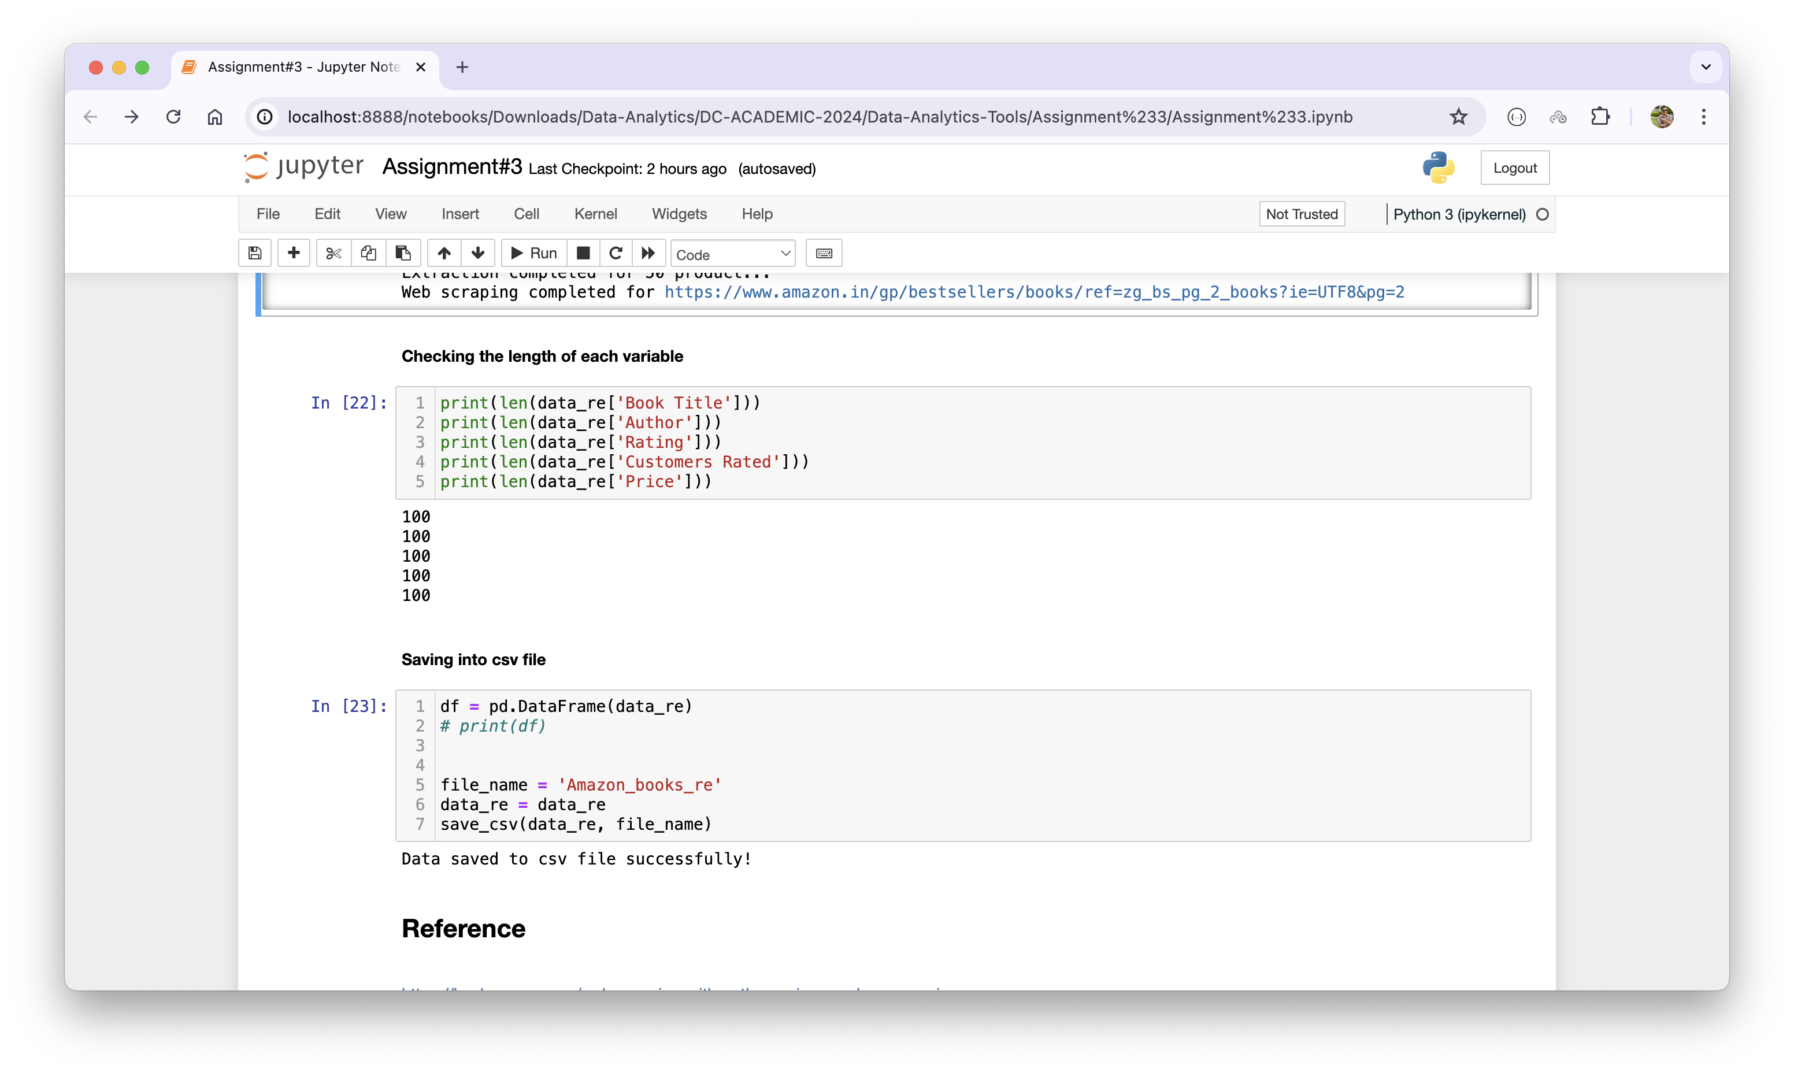

**Section – 3: Saving into .csv file using collected data**

In this particular section, I have referred to data extracted in the first method (*Implementing web scraping using Beautifulsoup in Python*) of above section and then called the helper function to save it into .csv file as below:

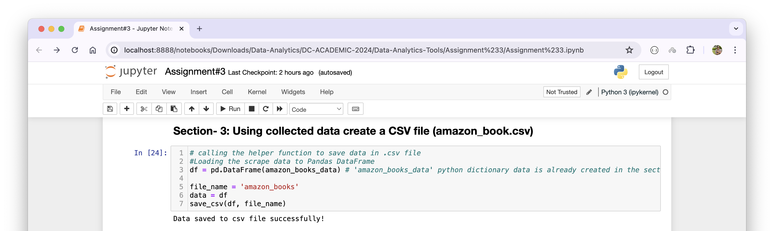

Here, the saved file is named as ‘amazon_books.csv’ and the DataFrame is ‘df’.

**Section – 4: Loading ‘amazon_books.csv’ file and showing; the size, head, and info**

Under this section, I have leveraged the . read_csv() method of Pandas to read the saved ‘amazon_books.csv’ file. Further, the size of the loaded data frame has been shown by calling .size property of the Pandas. It is the count of total elements found in the loaded data, which is 500 in the case of ‘amazon_books.csv’ file. Similarly, .shape property would tell us about the count of total number of rows or data points by the total number of attributes or columns. In this case, its 100 by 5, meaning 100 records of books with 5 attributes of the book such as Book Name, Author, Rating, Customers Rated, and Price. Furthermore, .head() method displays the first 5 records which is similar to ‘SELECT * FROM amanzon_books LIMIT 5;’. Lastly, .info() shares about the data type and the columns’ names as shown below:

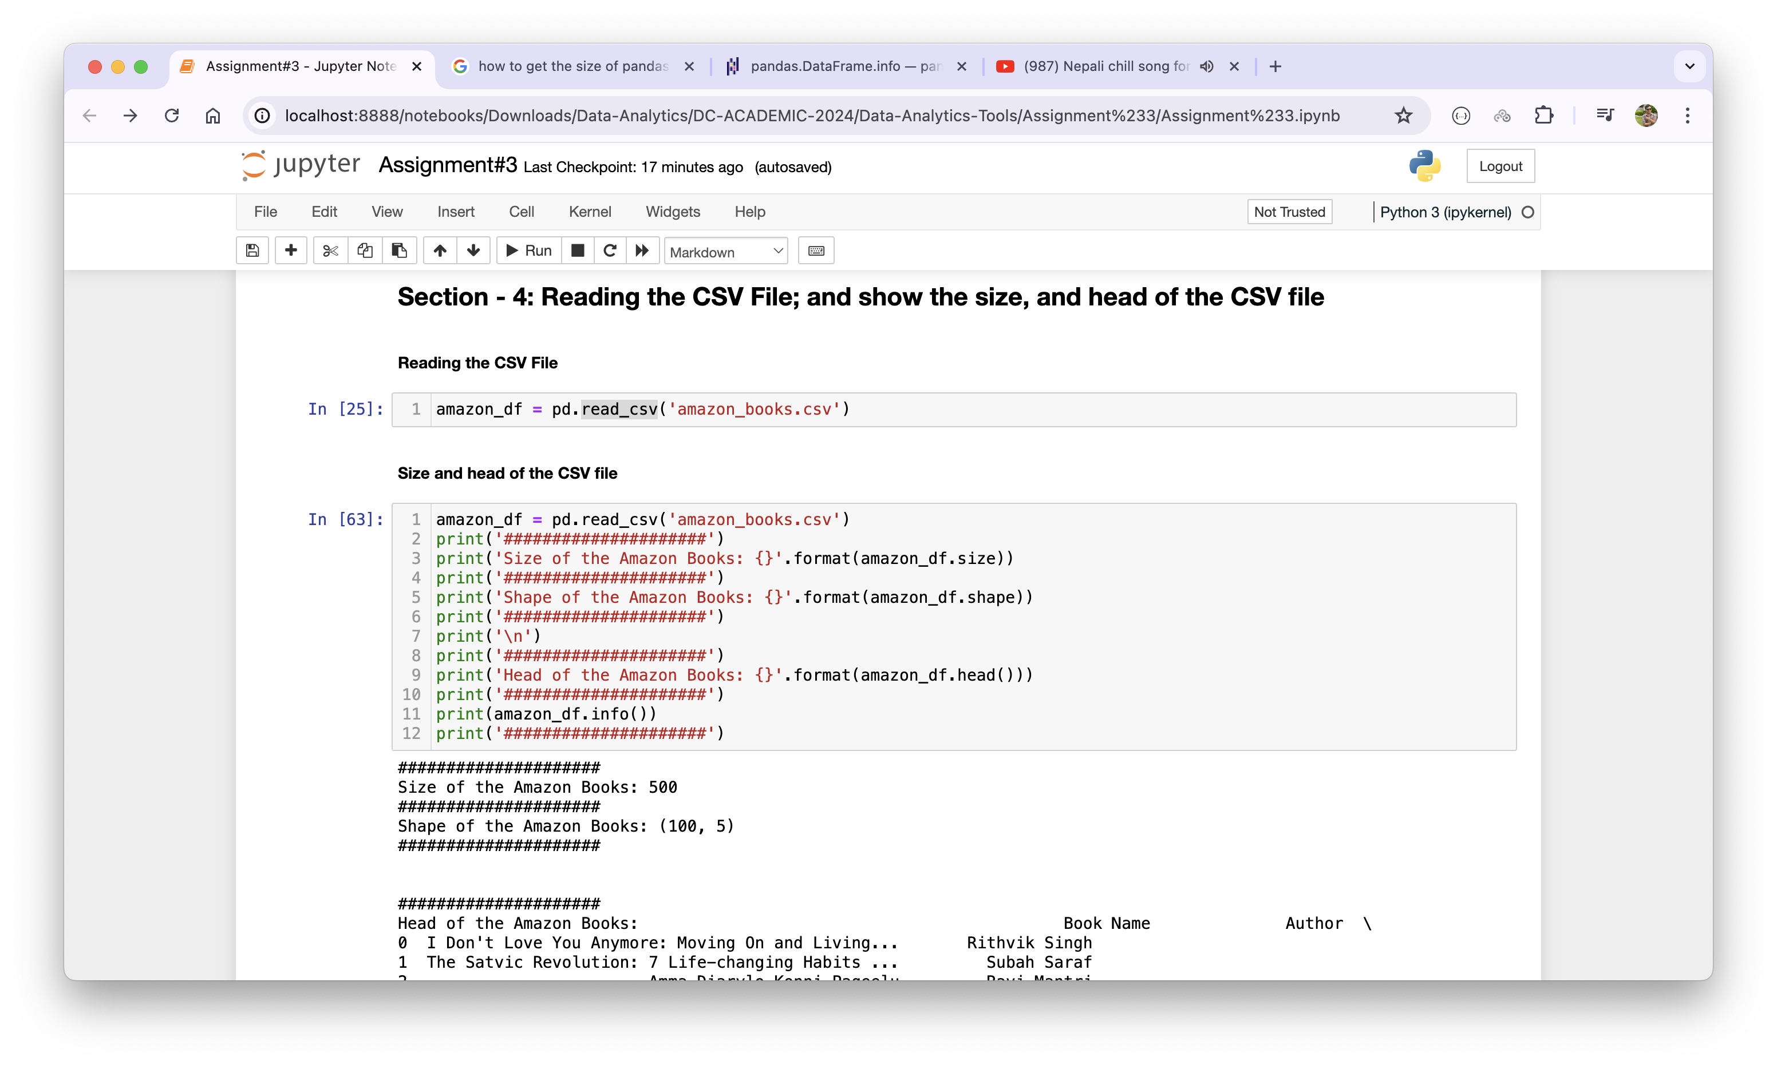

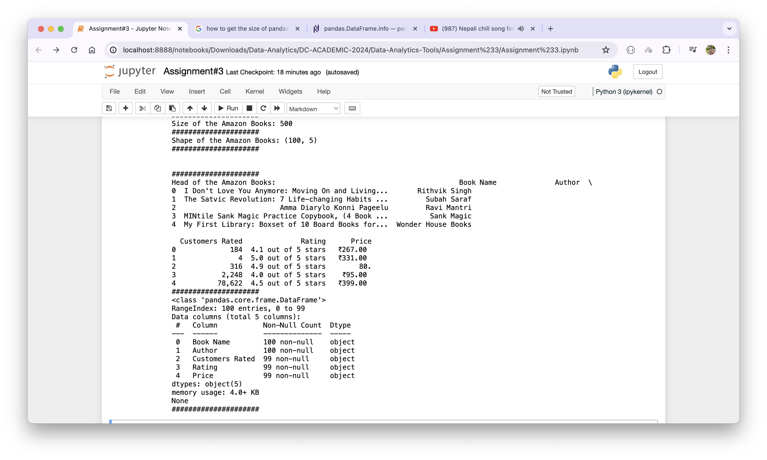

**Section -5 Checking missing values and handling**

Before diving into the Exploratory Data Analysis (EDA), it is necessary to check if there is any missing value which is ‘NaN’ in case of Pandas (stands for Not a Number). In our case, we found three missing data each in three columns; Customer Rated, Rating, and Price. When there is a NaN value, there are multiple ways to handle it. One of the ways is that we can fill the missing data with some values like the average value using .fillna() method. Further, we can use replace() and interpolate() methods to fill the missing data as well (GeekyforGeeks, 2024). Also, we can drop the missing data using .dropna() function. In our case, we will be dropping out the missing data as below:

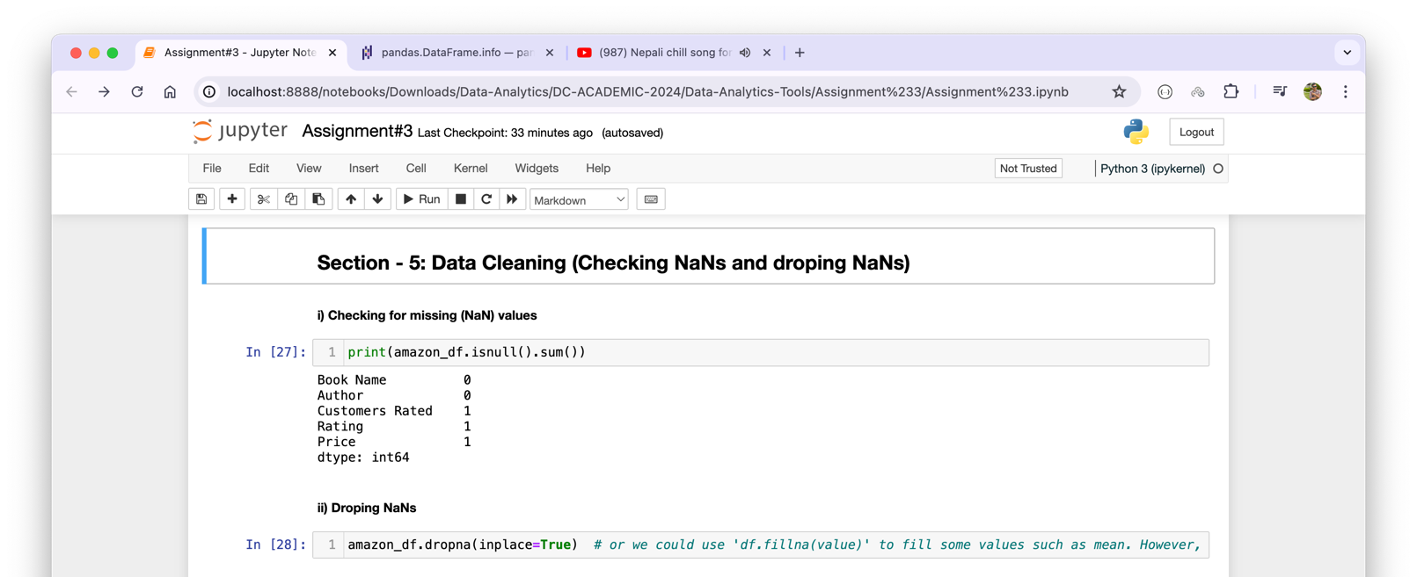

**Section – 6: Exploratory Data Analysis (EDA) of Amazon Books**

In this section, we engage in preprocessing of amazon_books data. We have already worked on handling the missing values in the above section.

Firstly, we work on ‘Rating’ variable. It should be in the numeric form. Thus, we have used .replace() method of Pandas to cut out ' out of 5 stars' from the each existing data of Rating. Then, it is casted to ‘float’ data type and then to numeric value which is shown as below:

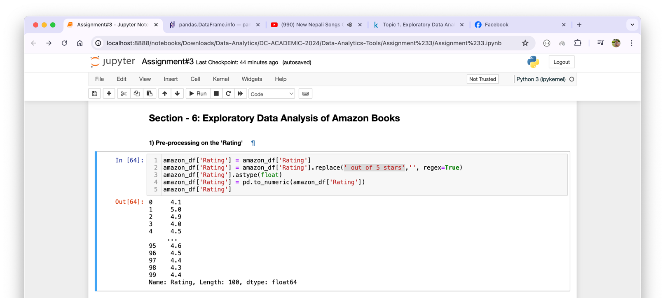

Similarly, ‘Customers Rated’ variable also has been pushed to preprocessing. In this process, I have replaced the comma (,) with nothing from the data and then changed the data type to integer using .astype(int) method.

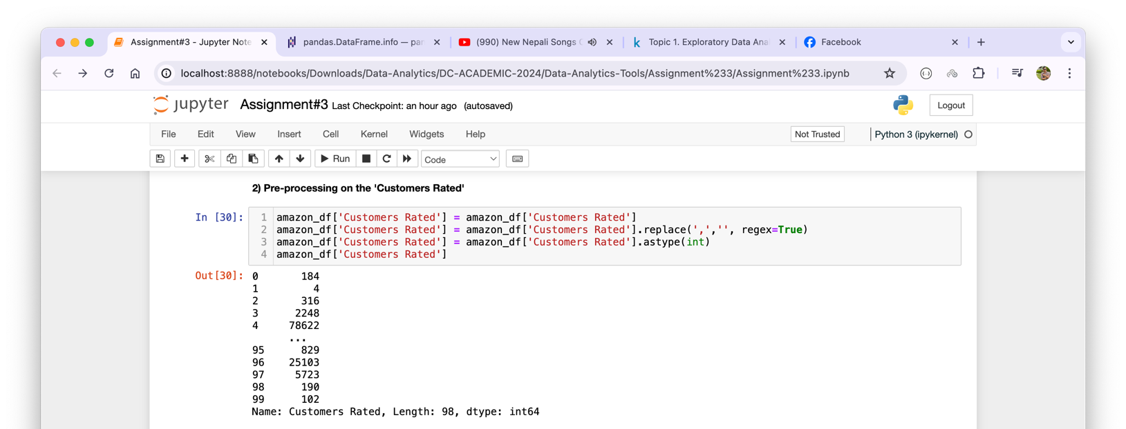

Lastly, in the case of ‘Price’, I have removed special characters like ‘₹’ and ’comma(,)’. As instructed, then I converted the data to number after converting it to a float.

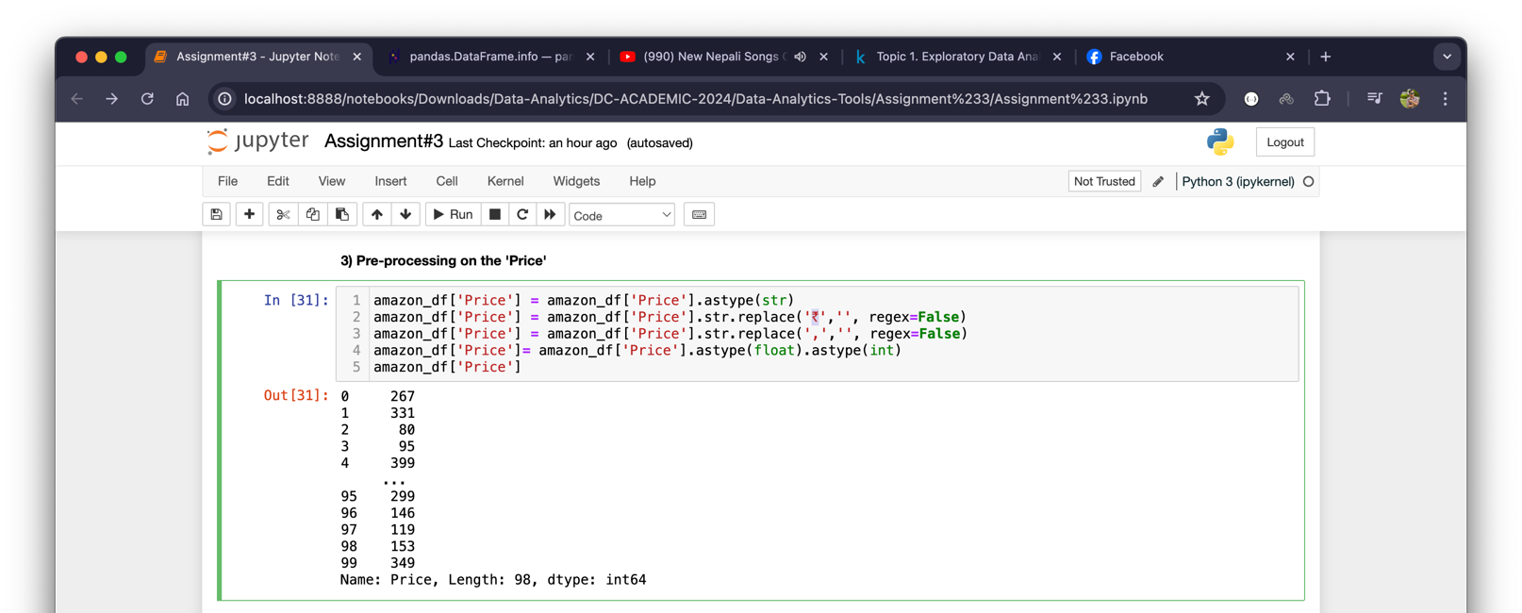

After all, the processed data looked like as below:

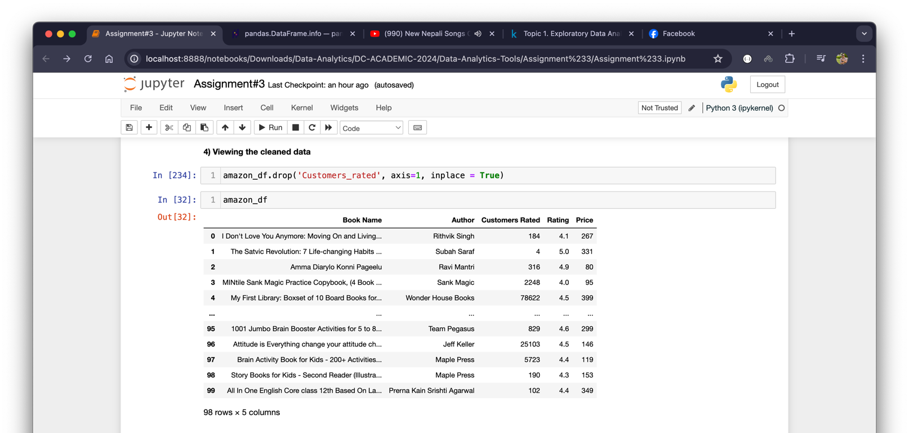

Now, the datapoints is shrunk to 98 from the 100 records. It means, in total, we dropped 2 records which were missing data.

Finally, I performed the descriptive statistics analysis. For this, I leverage the describe() method of Pandas which gives us the summary of mean, standard deviation, percentile, etc. as below for numeric fields, not the categorical fields:

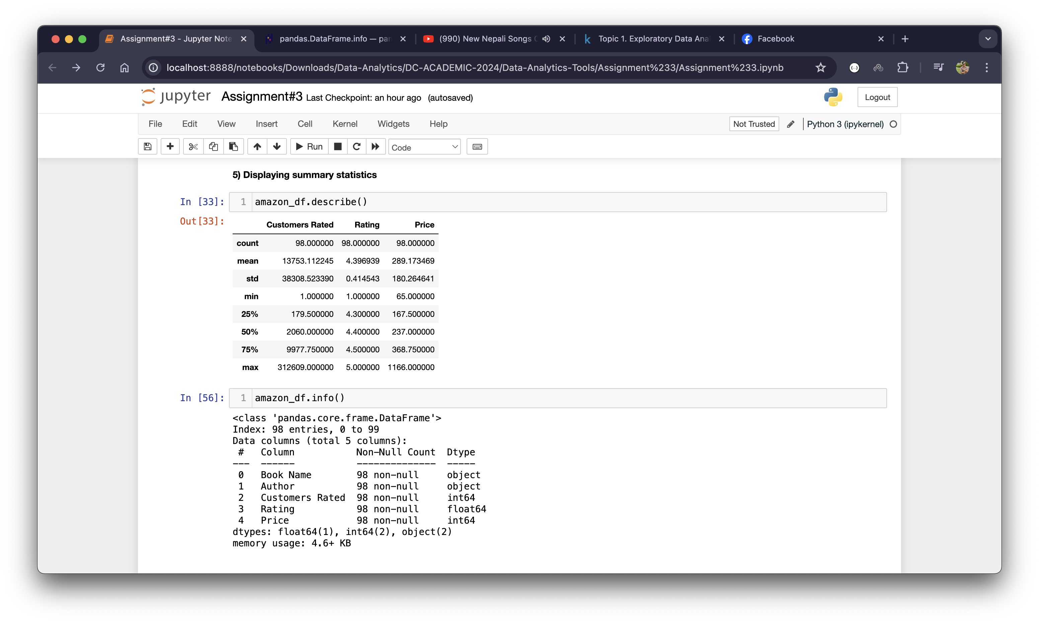

As shown in the summary, there are total 98 datapoints. The average number of customers who rated the best-selling books in Amazon is about 13,754. Similarly, the average distance from the average number of customers who rated books and the actual number of customers who rated the books is approximately 38,309. Further, the number of customers who rated the books in Amazon platform ranges from 1 to 312,609.

In the case of rating, customers rated the books in both extreme of satisfaction (worse and the best) because there are customers who rated just 1.0 out of 5.0 and also there are customers who rated 5.0 out of 5.0. Furthermore, the statistics show that most of the customers are satisfied as the average rating is 4.4 out of 5.0.

In terms of books’ price, the average price of the book is ₹ 289.17. The data shows that the books’ price ranges from ₹ 65 to ₹ 1166 wherein the lower 75% of the books are priced approximately ₹ 369 and below.

**Section – 7: Listing the Authors Highest Priced Book (i.e., based on price): show your result (at least top 25 highest priced book) as a data frame as well a Bar diagram.**

This section deals with listing the top 25 book names, authors, and their corresponding prices. To get this output, the sort_values() has been implemented by passing two arguments by=’Price’ and ascending=False:

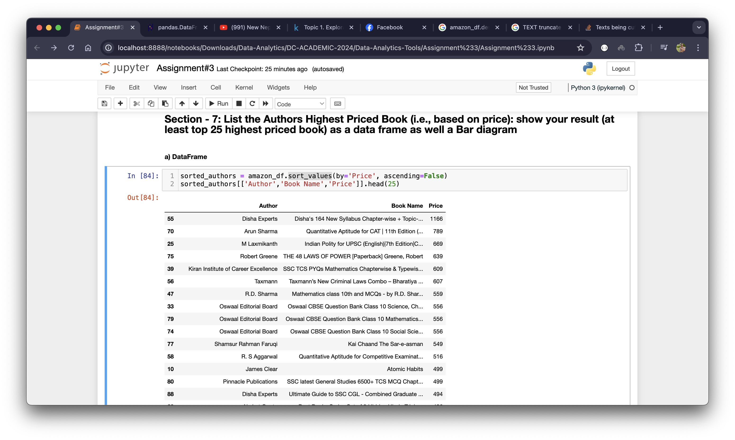

The output shows that the Disha Experts’ book related to JEE which cost ₹ 1166 followed by Quantitative Aptitude by Arun Sharma and so on. Further, I have plotted the above output into a bar chart as below:

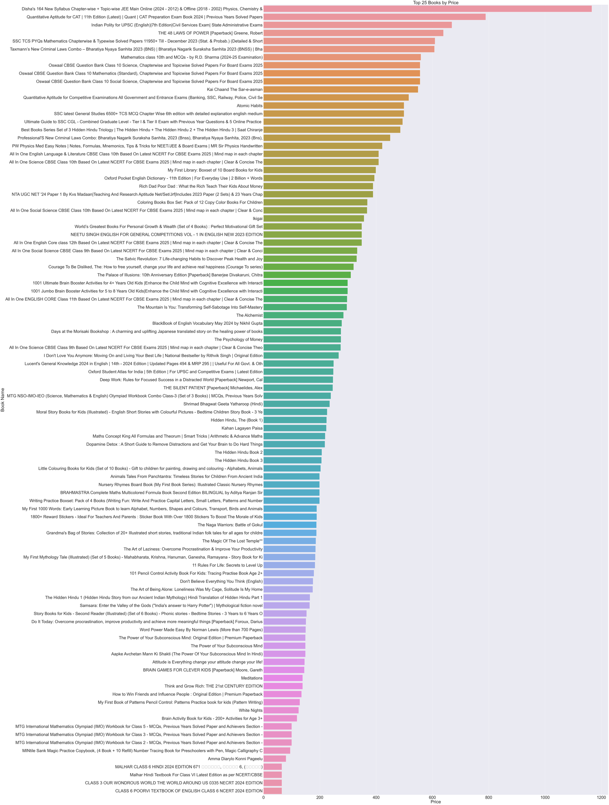

Above shown bar graph illustrates the top 25 books based on their corresponding prices. It shows the books data in descending order based on their prices.

**Section – 8: Show top Rated Books and Authors with respect to the highest customers rating (i.e., based on rating score): Show your result as a data frame as well as a Bar diagram.**

This section requires us to show that top rated books and corresponding authors. I have used the sort_values() method of Pandas passing ‘by=”Rating”’ and ‘ascending=False’ as arguments. Once we get the output, the output is filtered using only ‘Book Name’, ’Author’, and ‘Rating’. Further, only top 10 records are being shown:

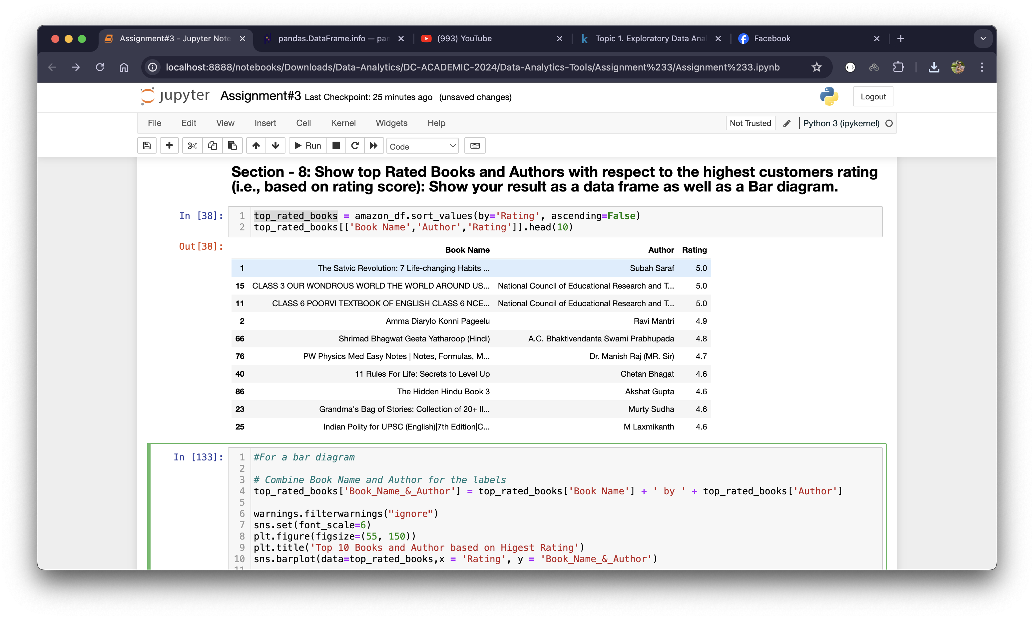

The output bar diagram reveals that there three top rated book ‘The Satvic Revolution: 7 Life-changing Habits’ by Subah Saraf, ‘CLASS 3 OUR WONDROUS WORLD THE WORLD AROUND US’ by National Council of Educational Research, and ‘CLASS 6 POORVI TEXTBOOK OF ENGLISH CLASS 6’ by National Council of Educational Research which are being rated 5.0 out of 5.0, followed by 4.9 and all the way to 4.6. Following is the graphical representation of the same:

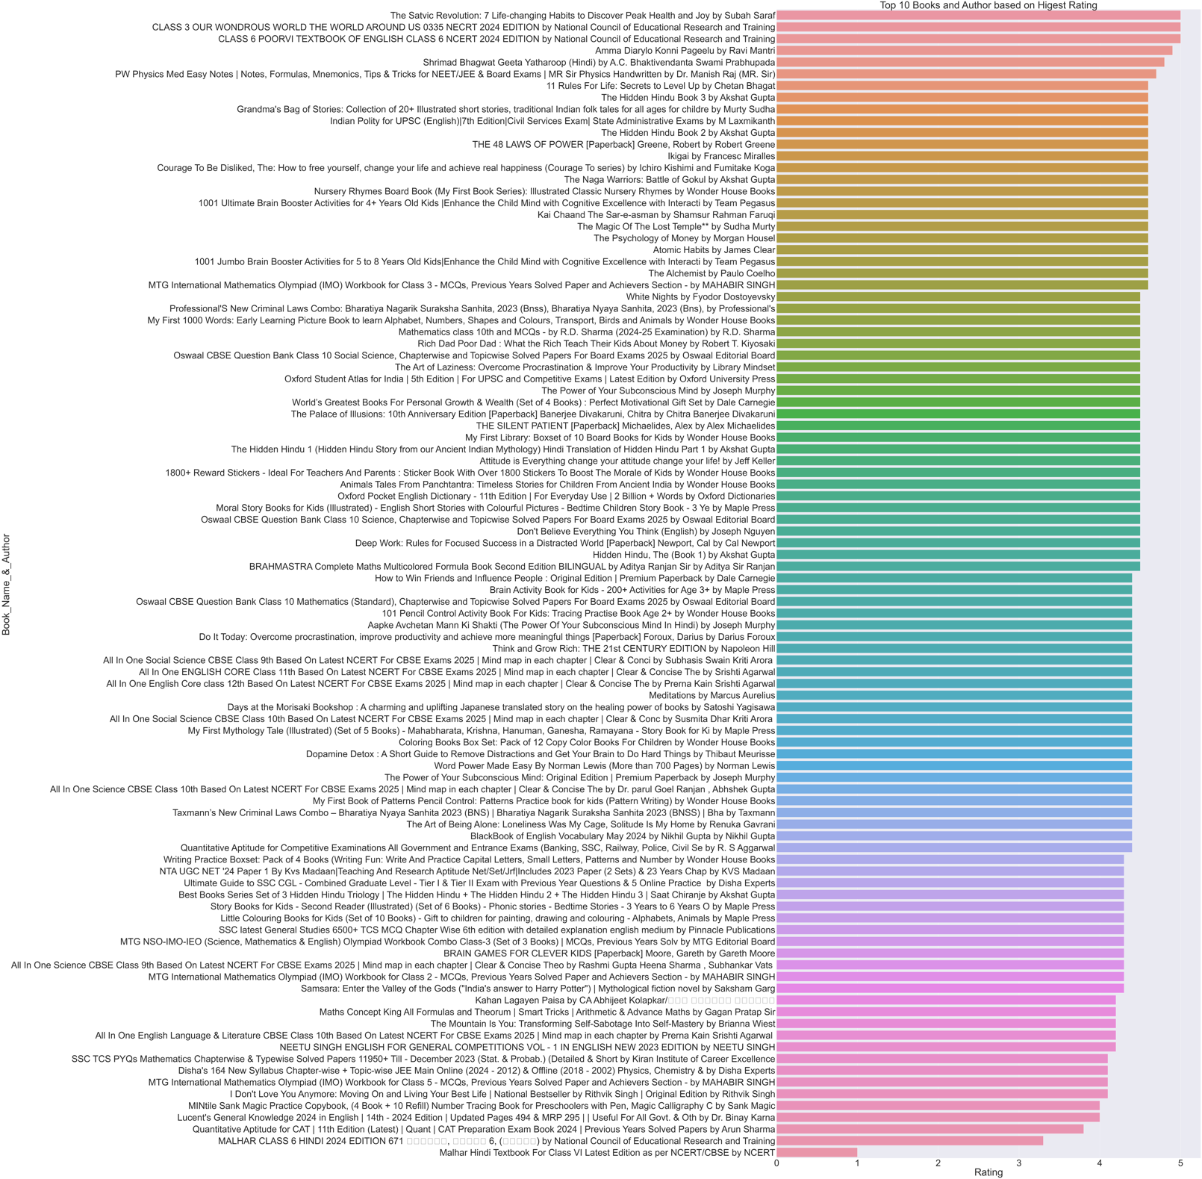

**Section – 9: Displaying the 15 Customer Rated Authors and Books**

Under this section, we have found out the top 15 books and their corresponding authors to whom most number of customers rated. Here, we have used sort_values() method of Pandas using ‘by=”Customers Rated”’ and ‘ascending=False’ as its arguments. The output shows that the over 312,609 customer rated for the book called ‘The Silent Patient’ which is way more number of customers for rating than any other books. As the second in the position, the book called ‘The Alchemist’ is there by ‘Paulo Coelho’ which has 148,959 as total number of customers for rating and so on:

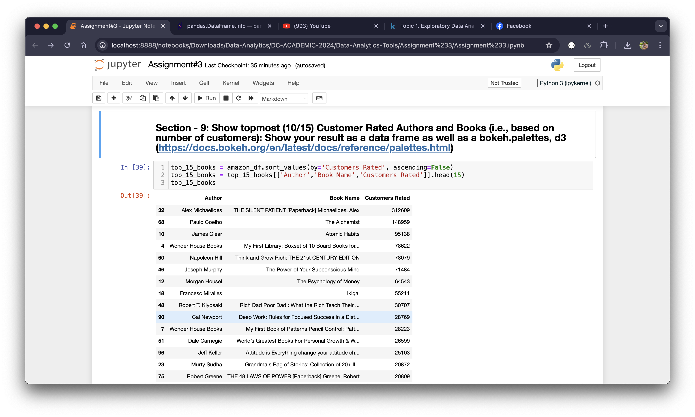

Following is the graphical representation of above output using ‘Bokeh’ is a Python library for building very interactive graphs and charts (Simplilearn, 2024):

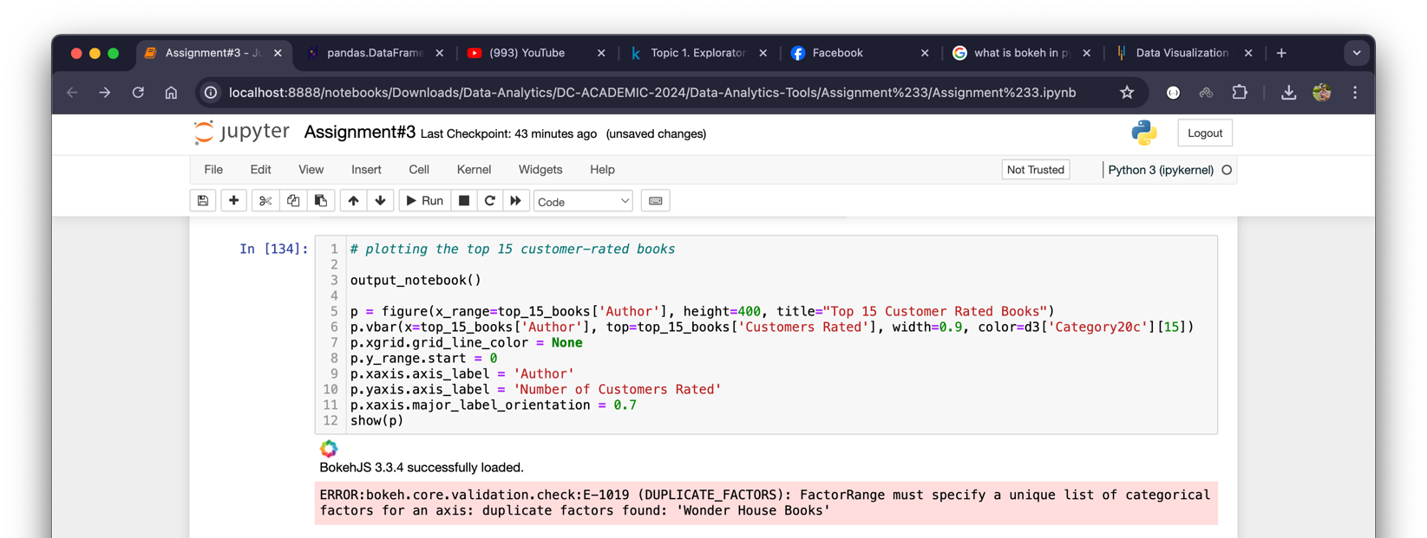

As you can see in the above picture, when we used the ‘top_15_books’ data frame, Bokeh threw an error, saying ‘duplicate factors found’. This is because the same name author is repeated. To solve this problem, we can add both the ‘Author’ and ‘Book Name’ but in our case, the book name is longer as well as some author name is longer. Therefore, to sort this out, instead of top 15, we will pick only top 10 as below:

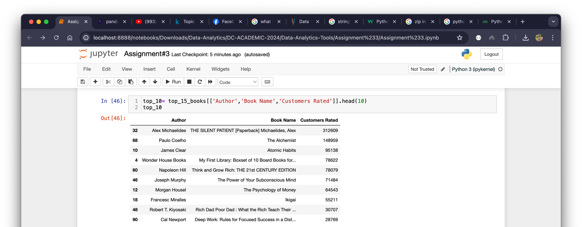

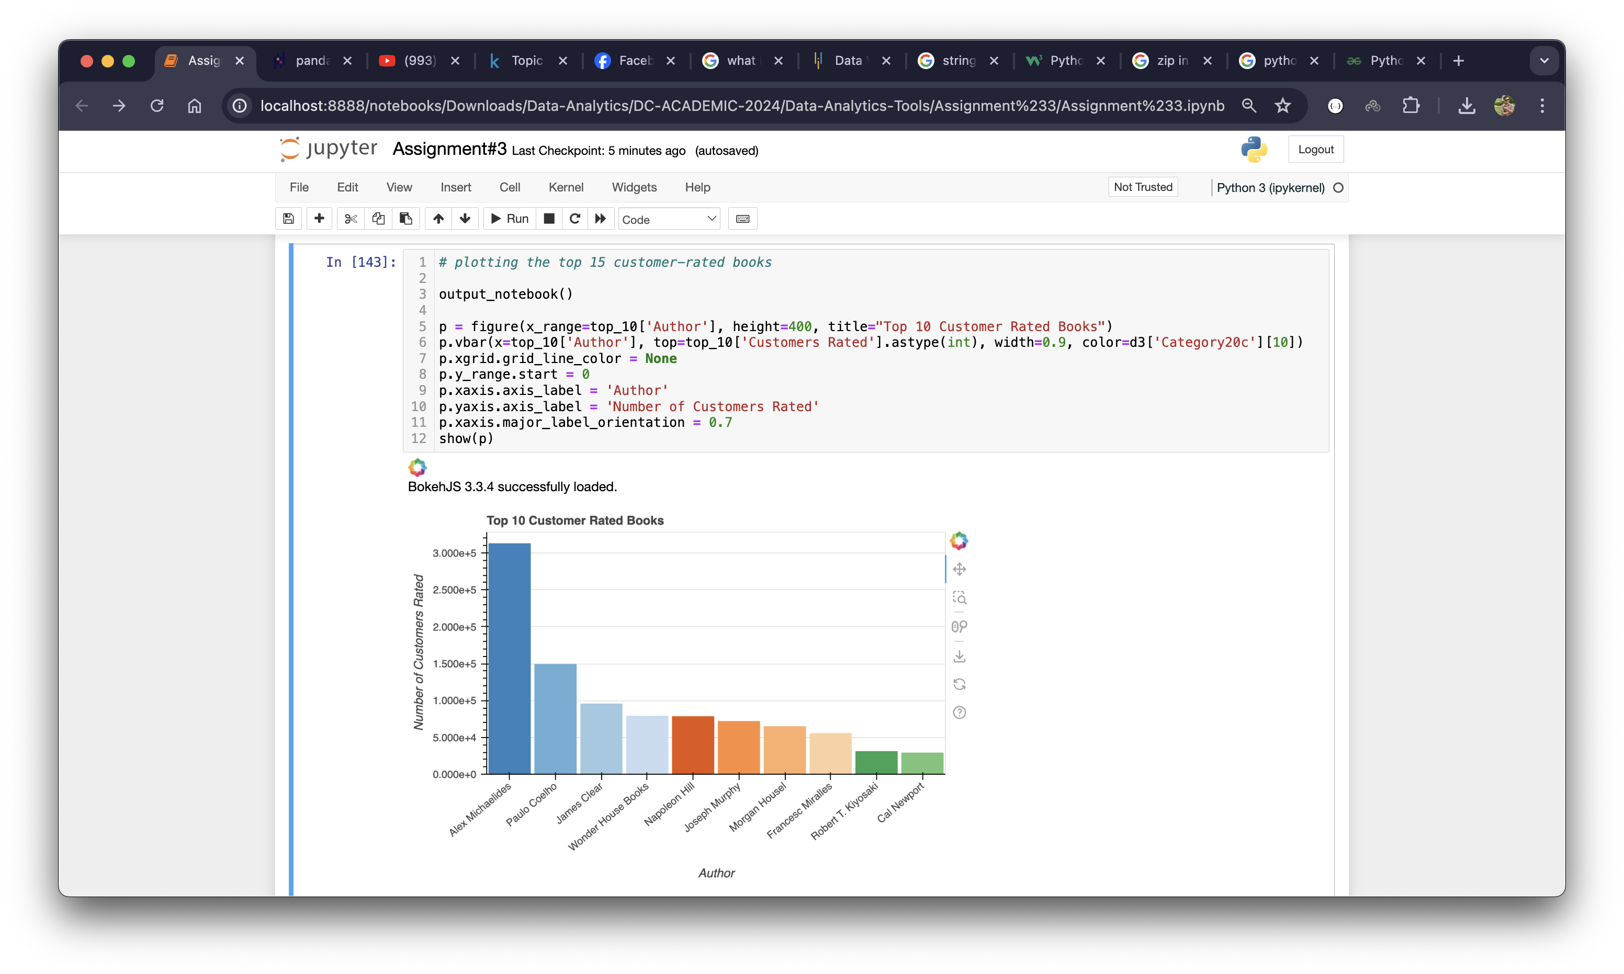

Now, Bokeh is operating perfectly just fine. The graph shows that the author ‘Alex Michaelides’ is the topper author when it comes to the number of customers who rated books and authors.

**Section – 10: Three web craping packages and their performance (processing time) measurement**

To perform above web scraping project, we have used “BeautifulSoup”,”lxml”, and “regex” as three different python packages. Each package has its own pros and cons. In terms of processing time taken by each package, we can measure their performance as below:

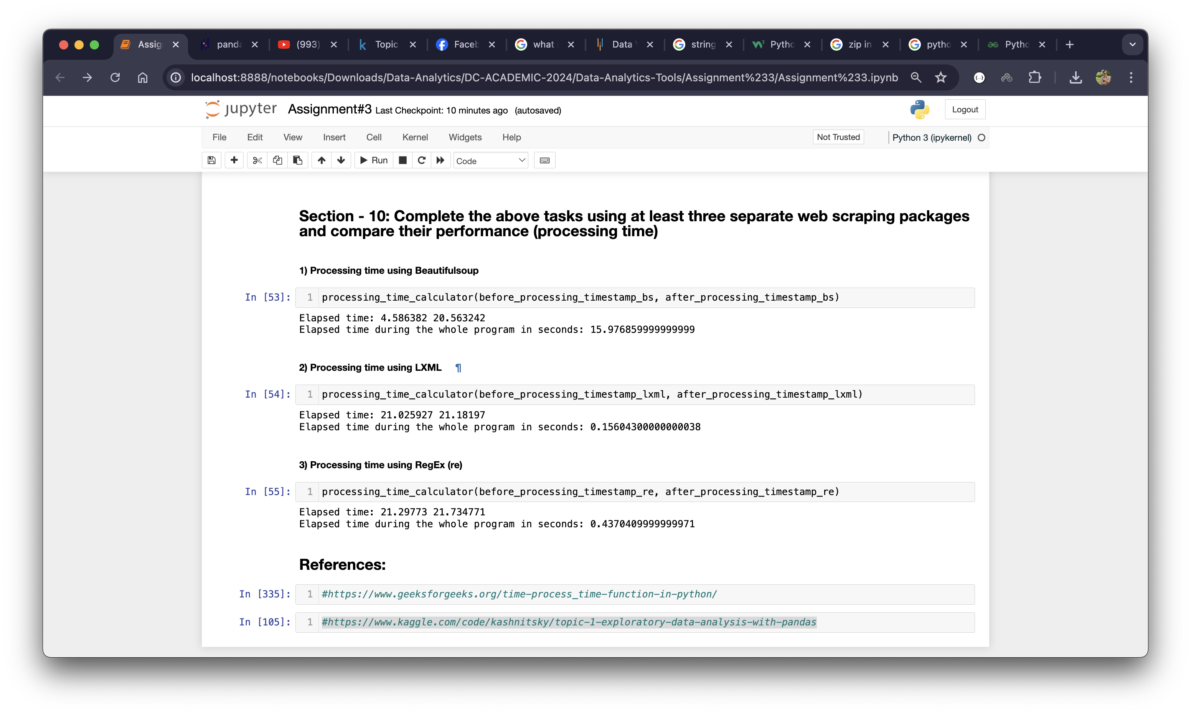

As the above picture shows that the BeatifulSoup has taken the most time than any other package which is almost 16 seconds whereas lxml took only 0.15 seconds and regex took only 0.44 seconds. The main reason for BeautifulSoup to take that much time is already explained in the above part. To recall it, we have extracted the most accurate price for each book using ‘Selenium’ and ‘Chrome’ as headless browser to send request to every individual URL of each product as human. Therefore, the program is taking much time to send request and extract the price from each rendered page. Here, lxml seems to be very lucrative in terms of cost and time which outperforms remain two other packages.

**Conclusion**

In a nutshell, web scraping is very essential when we have collected data from the website or APIs. There are lots of Python packages to perform this task. However, to select package, it depends on the requirements of the performer. Time, cost, and the skill to Python package could be some criteria for web scraping tool selection. To generate most valuable business insights, EDA is very essential. Followed by the selection perfect visualization tool is also equally important for a data analyst.

# References

GeekyforGeeks. (2024, July 11). *Working with Missing Data in Pandas* . Retrieved from GeekyforGeeks Web site: https://www.geeksforgeeks.org/working-with-missing-data-in-pandas/

Python Software Foundation. (n.d.). *re — Regular expression operations*. Retrieved from Python Software Foundation Web site: https://docs.python.org/3/library/re.html

Simplilearn. (2024, June 13). *Python Bokeh: What Is Bokeh, Types of Graphs and Layout*. Retrieved from Simplilearn Web site: https://www.simplilearn.com/tutorials/python-tutorial/python-bokeh